- Samsung Galaxy Watch 4 Classic
- Software Version: R880XXU1GWD6
- Wear OS Version: 3.5
- System version: 11
- Security software version: ASKS v4.0 Release 202230119
- Communication Protocol: Bluetooth
- Sensors: Accelerometer, barometer, gyro, geomagnetics, electrical heart sensor (ECG), optical heart rate sensor (HRM), bioelectrical impedance analycsis sensor, light sensor, hall sensor
- Gathers data from the array of sensors and analyzes it to compute and track various activities and bio-metrics such as stress level and heart rate
- It contains an Exynos W920 system on a chip, which itself contains an ARM Cortex-M4 core and an ARM Corex-A55 co-processor
- The user can actively interact with the device via the touch screen, two side buttons, and rotating bezel

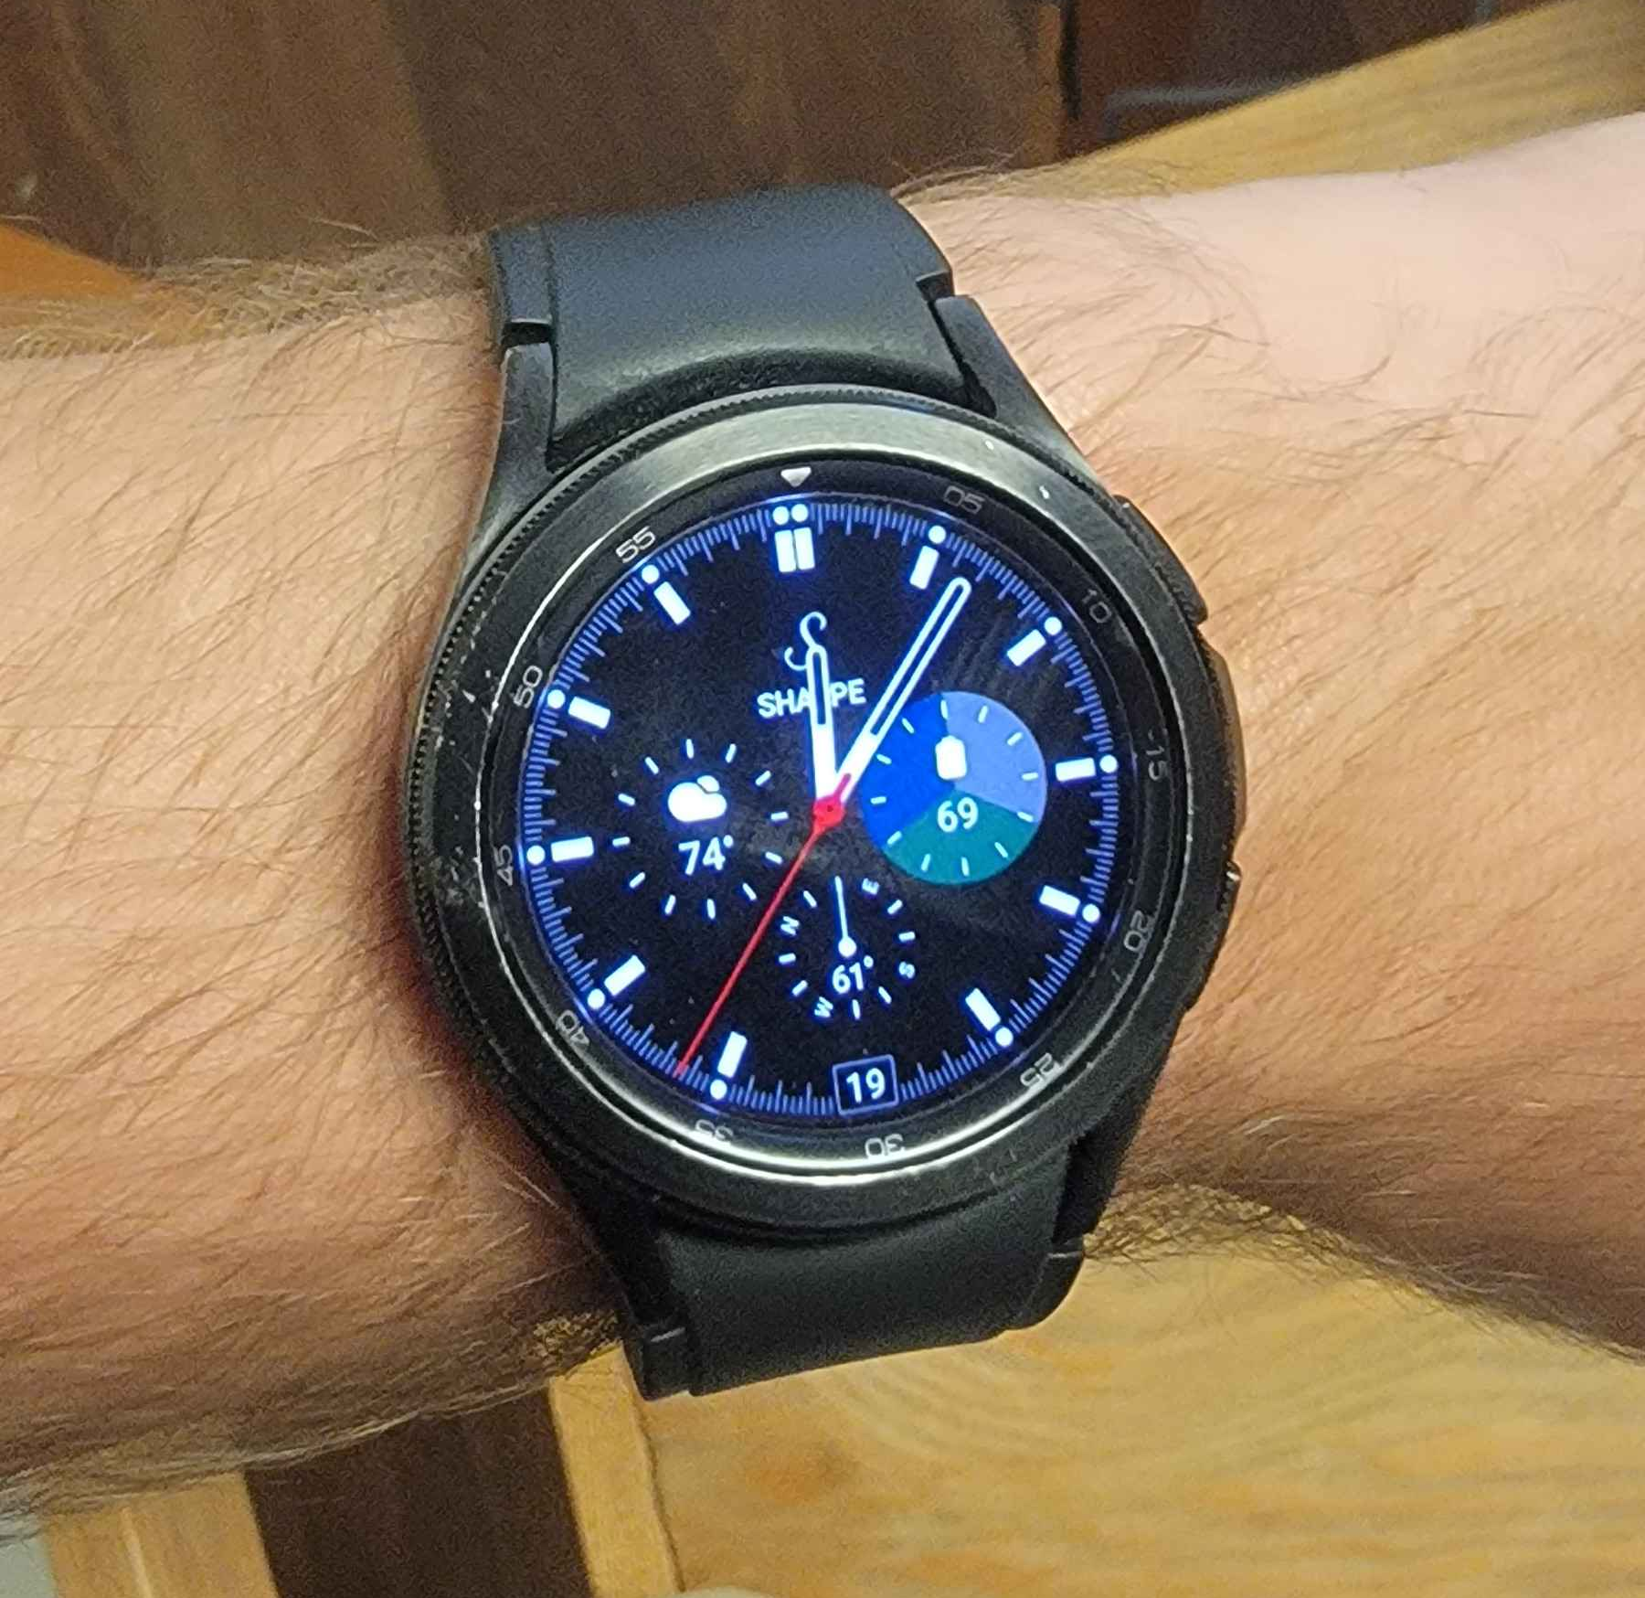
- Levoit 200S Smart Air Purifier
- Keeps track of filter life. Uses touch sensors on top to allow user to interact with the device directly.
- Computes filter schedules, timers, and when the filter should be changed
- Communicates over WiFi to connect to VeSync app servers
- Hardware and firmware information could not be found. There was no discussion online, and the user manual (found here) does not contain hardware or firmware information.
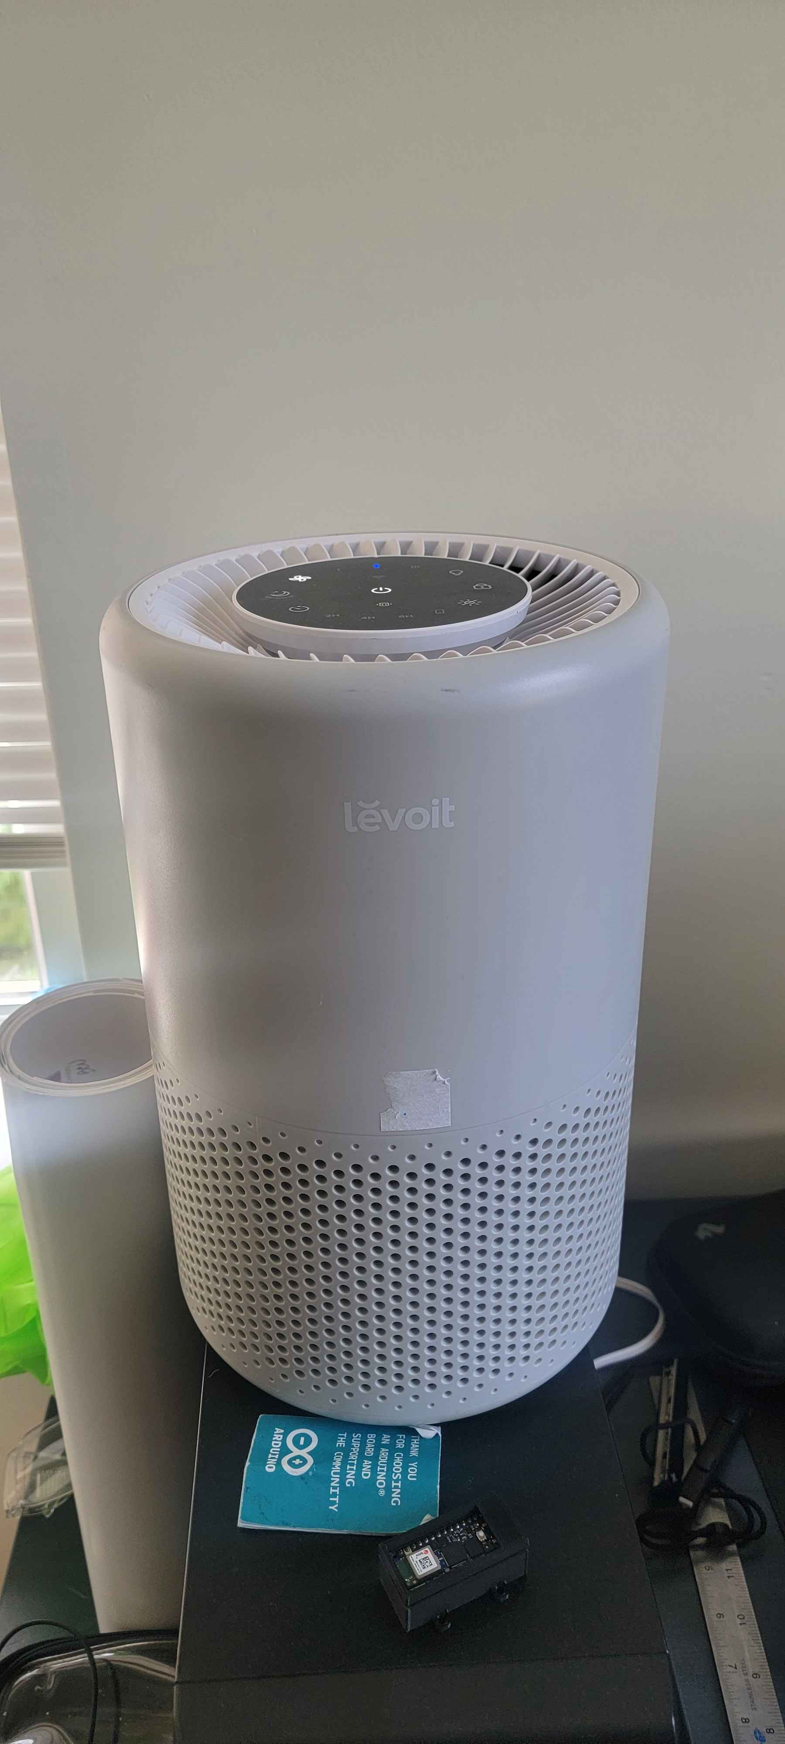

- Sonos Beam 2 Smart Sound Bar
- Uses microphone to listen for voice commands, and touch sensors on top to allow the user to directly interact with the device.
- Computes reflections off walls to optimize sound quality using Trueplay technology
- Has Amazon Alexa integration to process voice commands on Amazon servers
- Has WiFi, TV remote sync, HDMI eARC, and Apple AirPlay 2 connectivity
- Best guess at firmware version is 16.2
- Only information about processor is that it is allegedly 40% faster than its predecessor
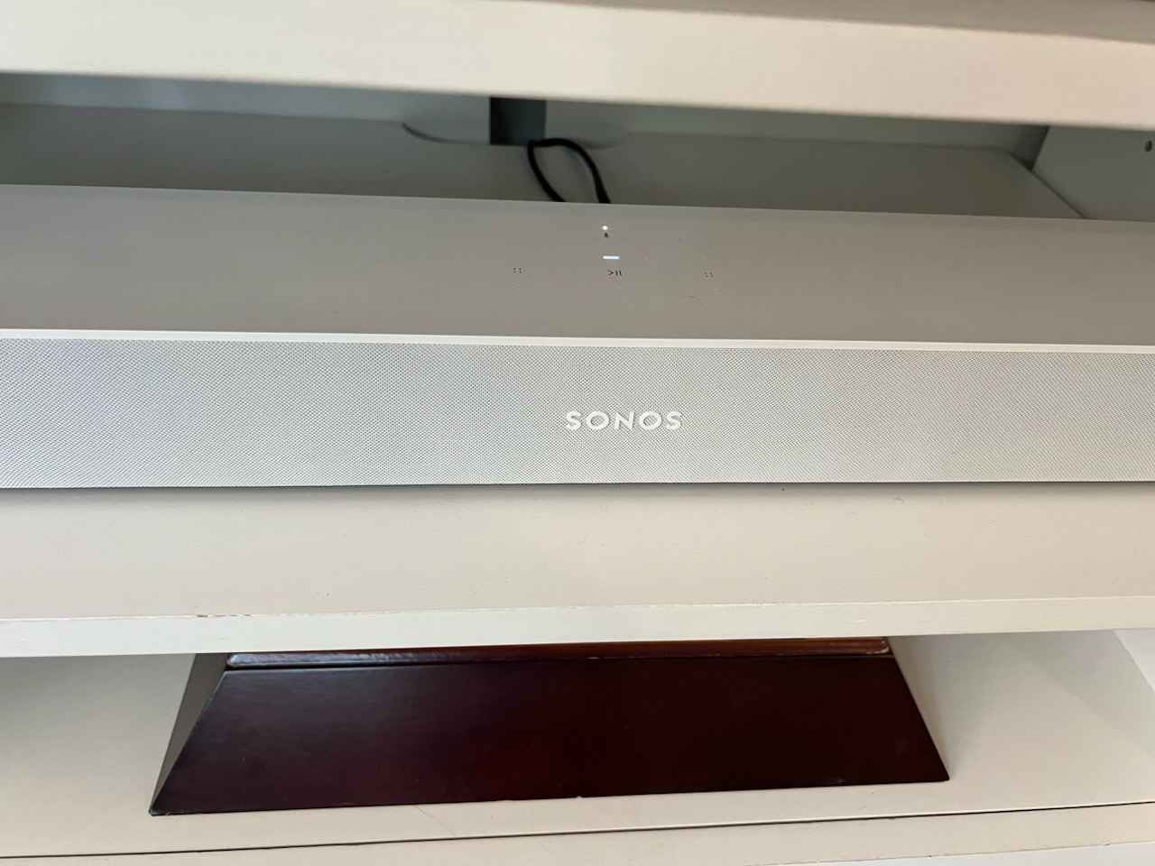

- LG Network BluRay Disc Player BD390
- Along with the BluRay/DVD reader, there is also an IR sensor for remote control
- Computes user inputs and displays a user interface. The device has YouTube, CinemaNow, and Roku-enabled Netflix integrations. It also performs signal processing to provide high-quality (for 2009) audio and video.
- Connectivity: LAN, WiFi, and various A/V interfaces. It also sports a front-facing USB port.
- The device contains several embedded processors. The main processor is a Broadcom BCM7601, and the BluRay processor is a MediaTek MT8575.
- The latest firmware version is Ver:BD.8.08.561.B
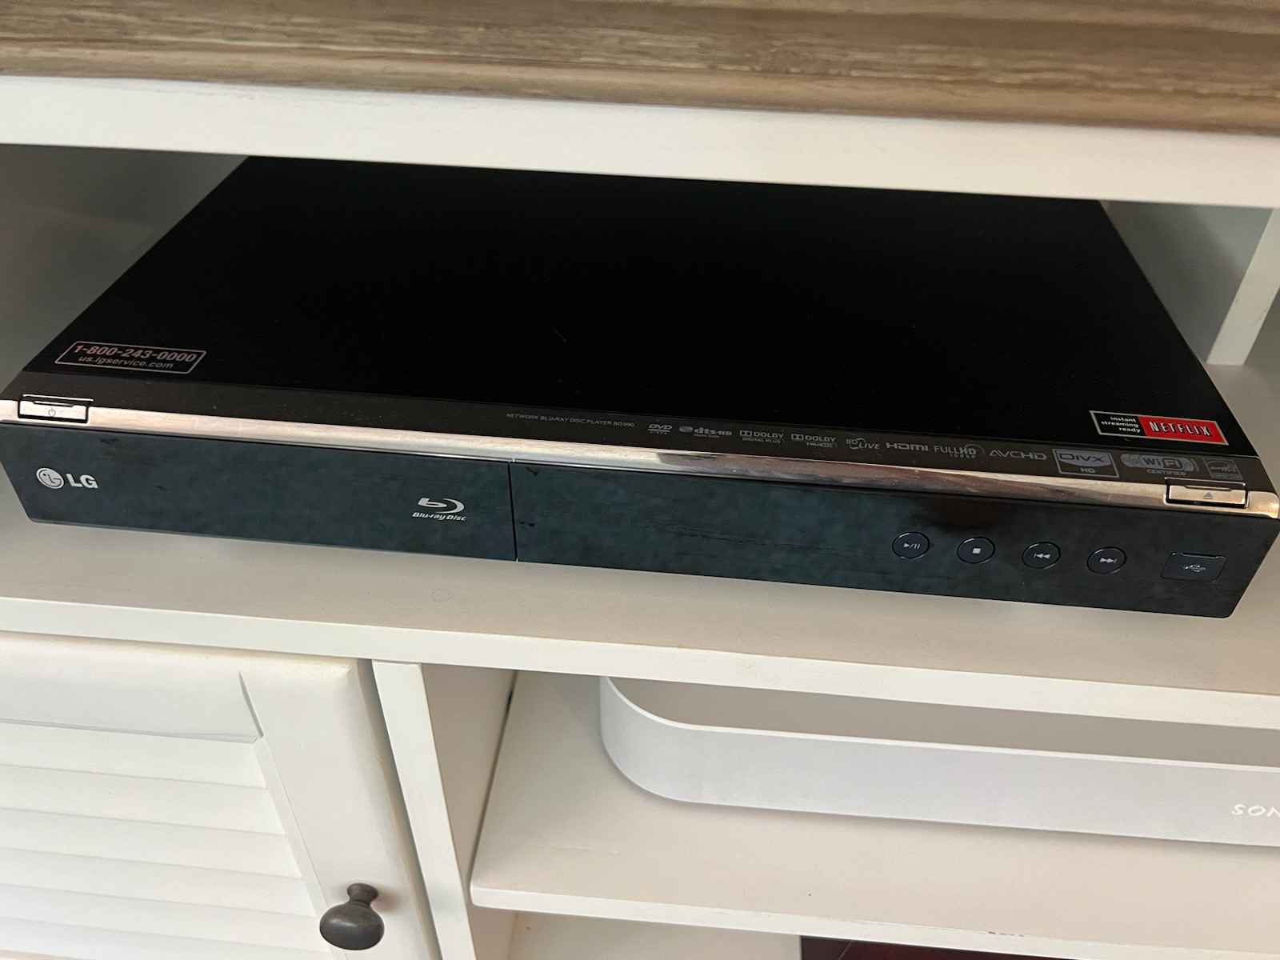

- LG Smart TV
- IR sensor for remote control
- Wireless screen sharing technology
- Has WiFi connectivity to connect to web-based apps
- Runs LG WebOS 6
- Multiplexes and processes audio and video signals from array of inputs
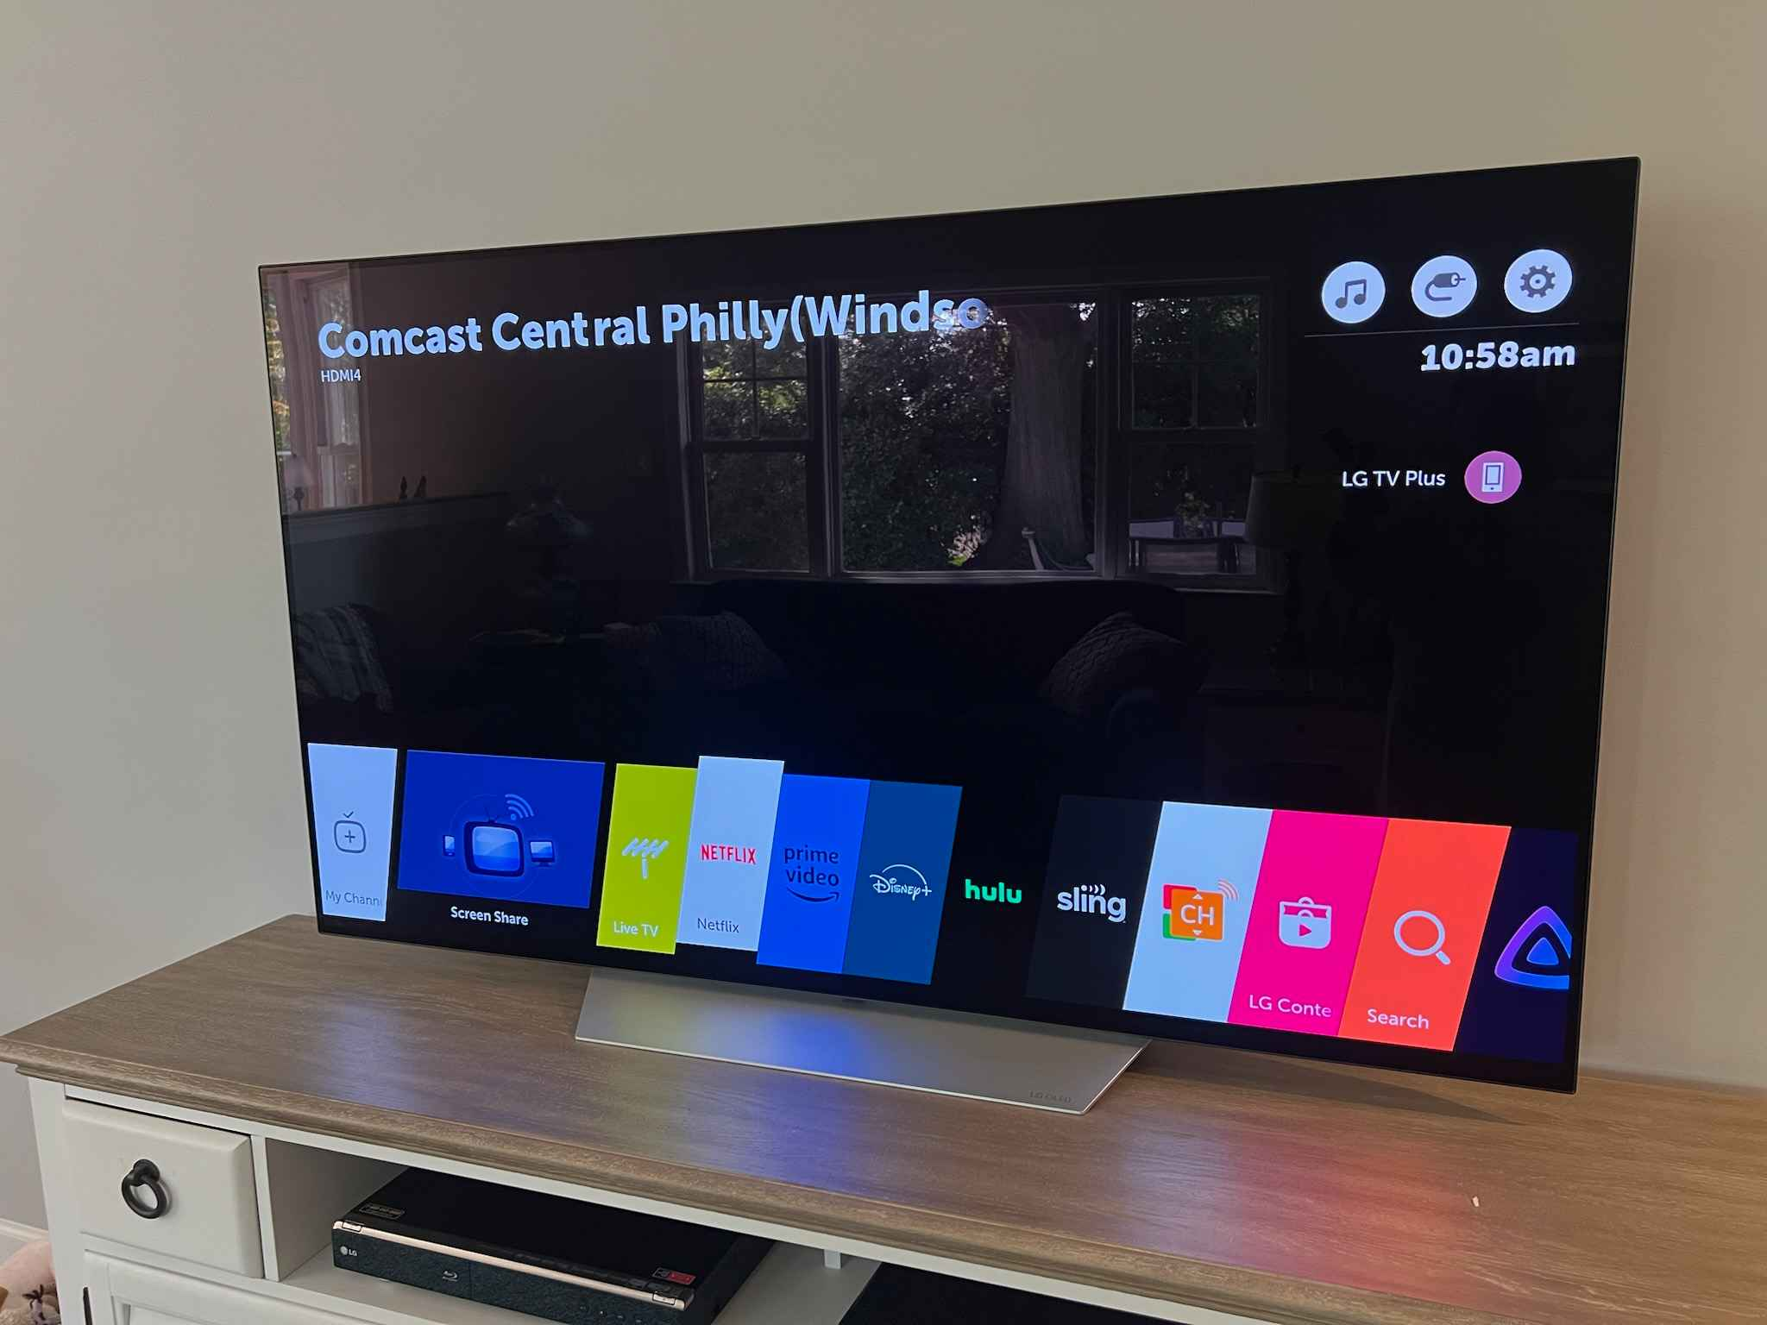

- Google Nest Learning Thermostat (3rd Gen)
- Senses temperature, humidity, user proximity and motion, ambient light levels, and the thermostat ring position.
- Connects to the nest app using WiFi
- Connectivity standards 802.11 a/b/g/n (2.4GHz/5GHz) Wi-Fi and 802.15.4 (2.4GHz) Bluetooth Low Energy
- Its operating system is based on Linux 2.6.37
- The latest firmware is version 6.2-27 released on May 3rd, 2022

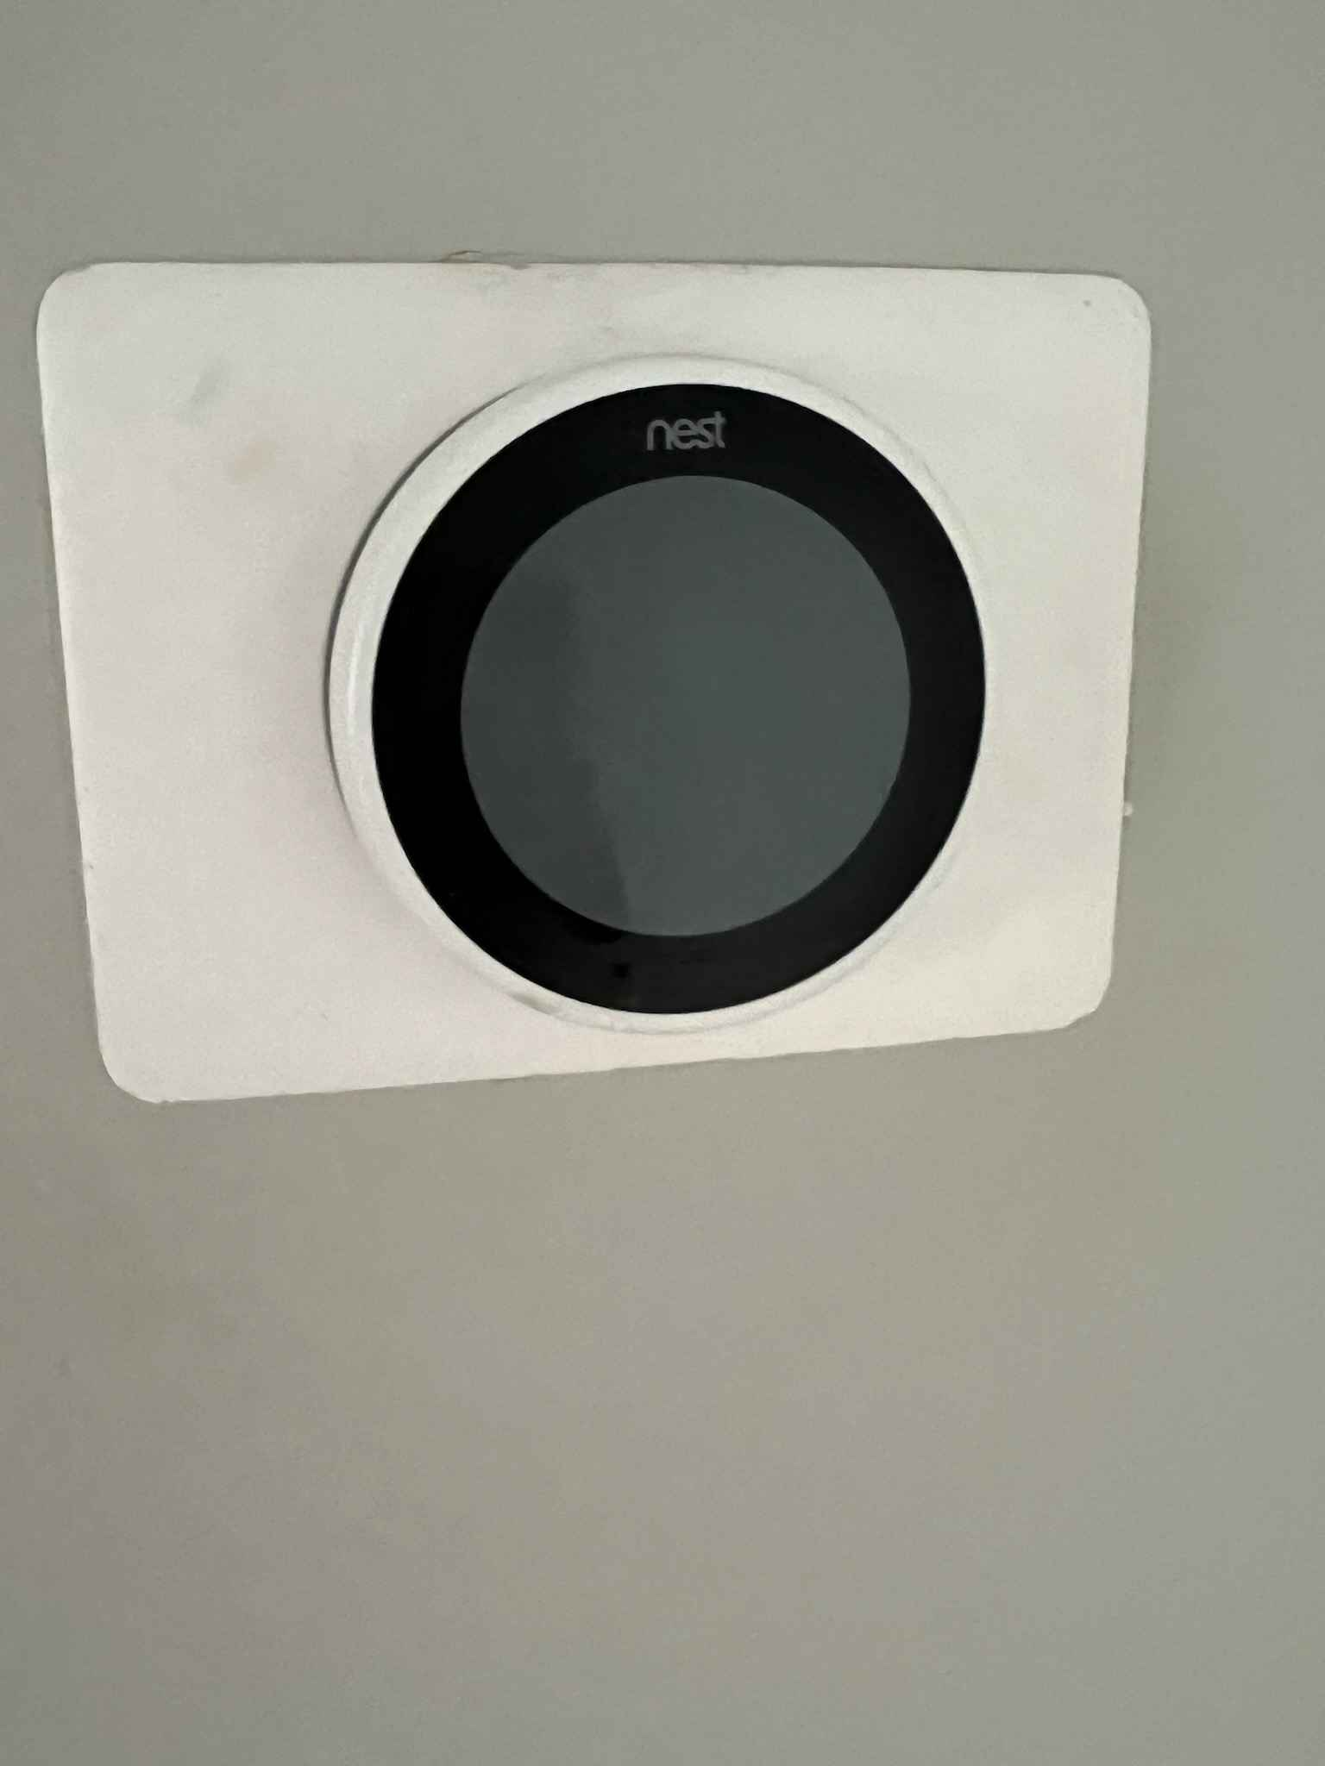

- LG 1.7 cu. ft. Smart Over-The-Range Convection Microwave with Air Fry
- Senses temperature and humidity
- Computes the optimal time and power level for the food. Based on a selected food type and information from the sensors.
- Connects over WiFi to allow the user to select ready-made meals via the ThinQ app to remotely send cooking instructions to the over.
- Could not find any service manual or discussions on firmware version or the embedded processor.
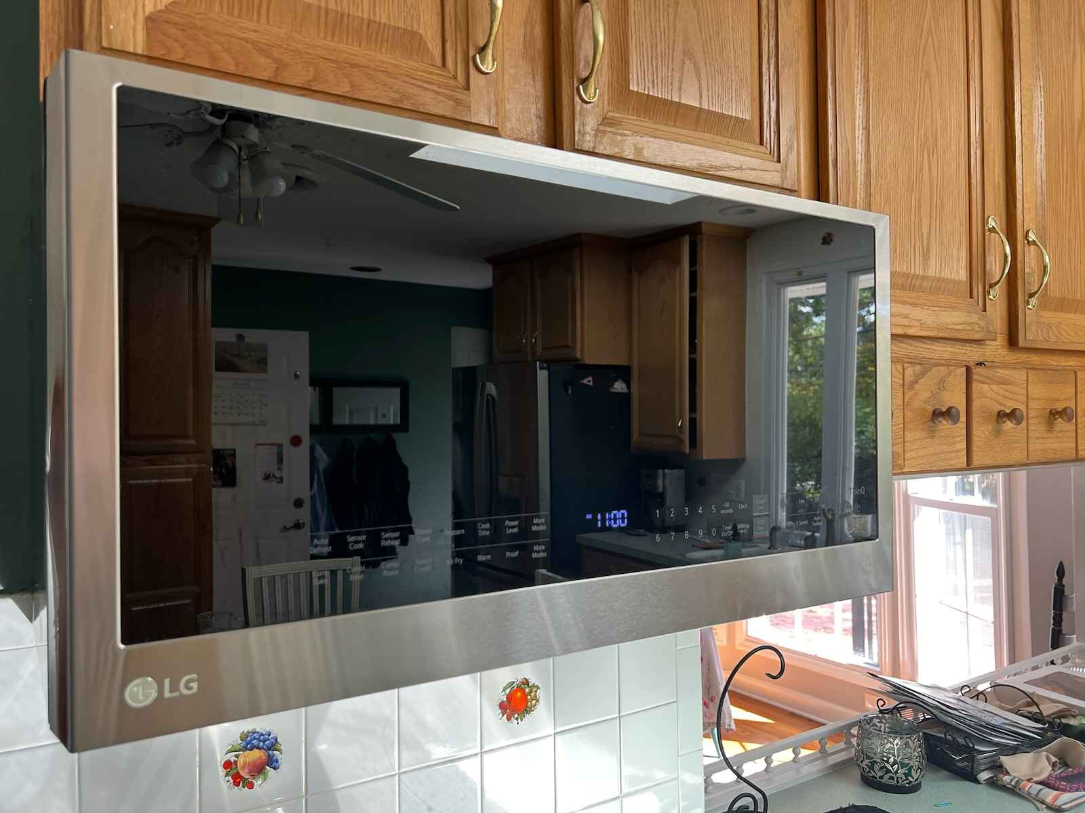

- LG Range with Smart Oven
- Senses oven temperature and stovetop power delivery
- Computes remaining cook times and how compatible (0 to 10 scale) cookware is with the induction stovetop
- Communicates over WiFi to enable LG ThinQ features such as remote oven control, burner status, and remaining cook time updates/notifications
- I could not find any information on the processor or the firmware
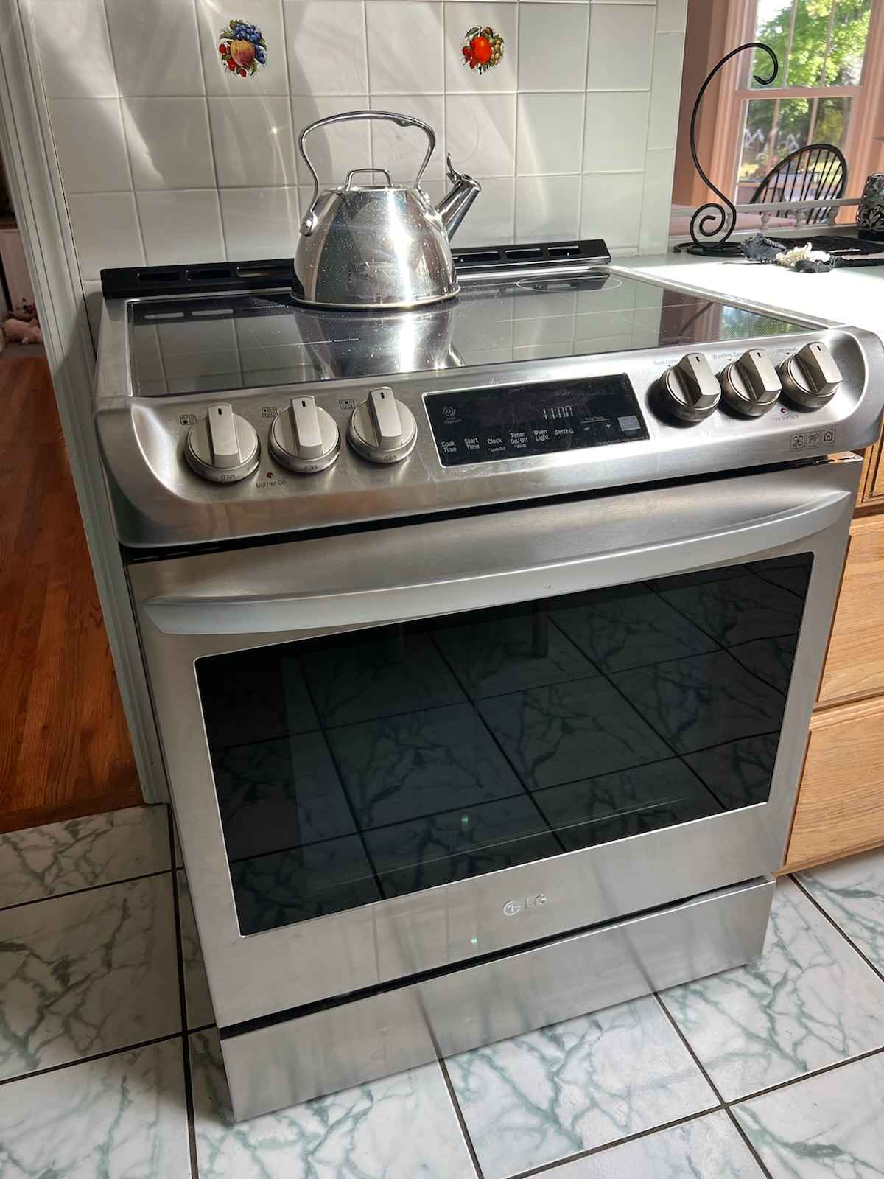

- Hydrow Smart Rowing Machine
- Senses the movement of the handle with a motor that is reverse-driven by the movement of the strap, generating an electric current.
- The embedded processor computes the rowing rate, the distance rowed, and the calories burnt.
- Has WiFi, Bluetooth, and Ethernet connectivity
- Bluetooth may be used for headphones, speakers, heartrate monitors
- Can be used with Strava and Apple Health
- Runs Android
- Internal hardware information is not publicly available
- Firmware information is not published (found on Firmware FAQ Page)
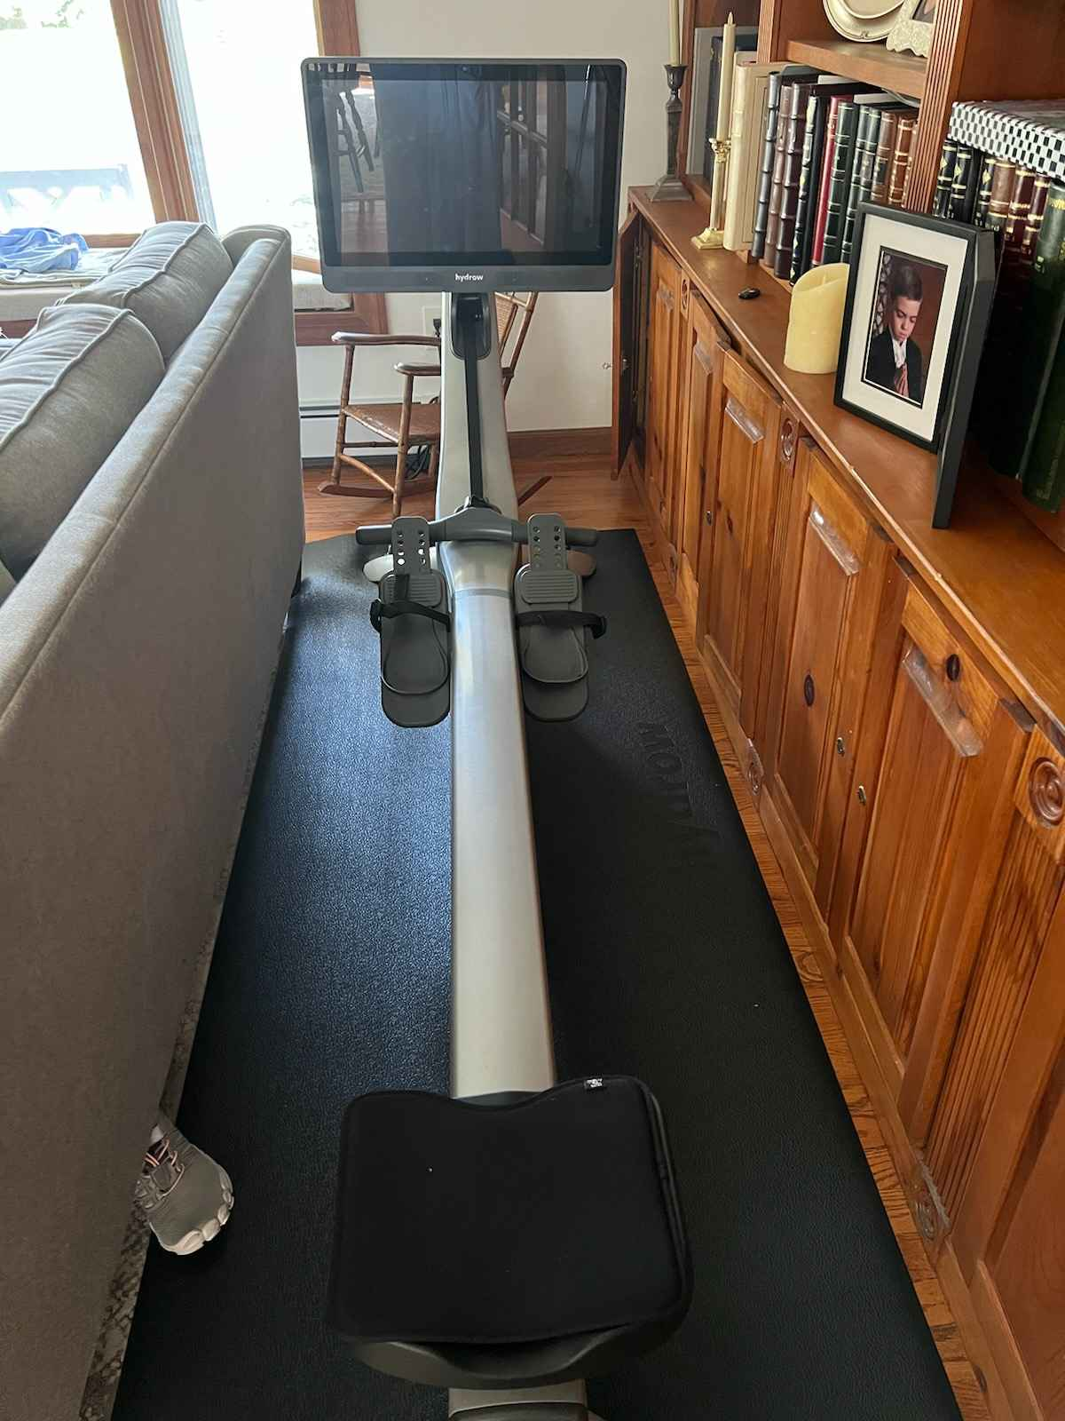

- Vankyo Projector
- Has an IR sensor for remote control
- Computes ±50° digital keystone correction
- Connects over WiFi and supports iOS and Android wireless screen-sharing technologies
- Software version V1.0.0.5:2023-04-23
- Processor information not found
