Project 4 – IoT Inspector – Aidan Sharpe
Unfortunately, I ran into several issues while attempting to complete this project.
- I live in on-campus housing and do not own the network, nor have contact with the network administrator. This issue potentially creates an ethical dilemma. Local IP addresses, MAC addresses, and device identification information are public information to anyone on the network. However, I would consider exploring the devices further a breach of privacy to their owners in neighboring residences.
- I run Linux on all of my personal devices. While I was able to install and run the IoT Inspector web server on my Fedora Linux 40 laptop, I did run into some technical issues as seen below. The error, at first glance, appears to be a bug regarding IoT Inspector itself, rather than a result of running on Linux:
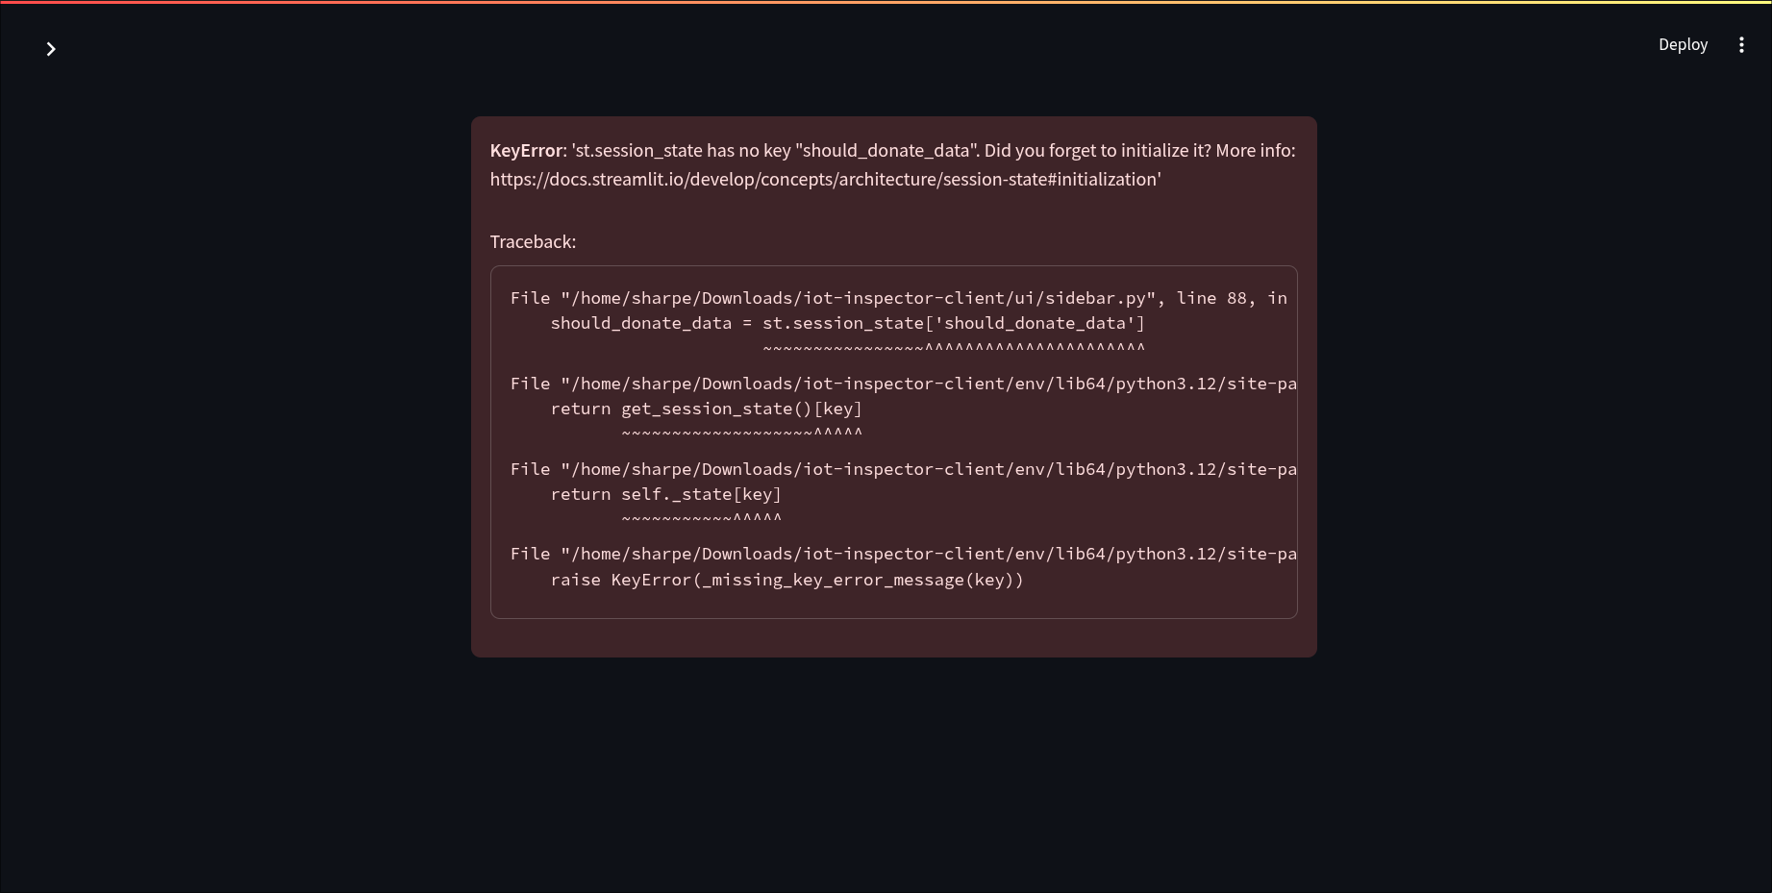

Despite these issues, I was able to retrieve a device list with some possible device identification information:
