Prerequisites:
- Review Week 6 discussion of virtualization and virtualized networking (slide content).
- Review Week 6 discussion and working knowledge of Linux commands (slide content and tutorials).
- Review Week 11 discussion and working knowledge of Linux commands (slide content and tutorials).
- Kali Linux access, either through a virtual machine or through a friend.
- Fresh Metasploitable Virtual Machine

Objectives:
The main purpose of this week’s exercise is to learn how to utilize basic firewall commands.

Resources:
https://www.howtogeek.com/177621/the-beginners-guide-to-iptables-the-linux-firewall/
https://www.garron.me/en/linux/iptables-manual.html

Call for Help:
Do your best to try the tasks below, if you’re confused, or need help, feel free to email or text me at any point and I will gladly try to help you. If you’re having an Issue, chances are, other people are as well, and I can update the instructions/comments/add content as necessary.

Tasks:

Setup
- You’ll need both Kali and Metasploitable Running simultaneously. You can do this by running a virtual machine, or by pairing with a friend and running metasploitable over the network (be careful here).
- Make sure you follow the instructions from lecture, and ensure the networks are setup accordingly with your layout.

Firewalls:
- Basic IP Tables Operation
  - Perform an NMAP scan of your metasploitable virtual machine from your Kali Virtual Machine.
Provide a screenshot. List the services that are currently available.
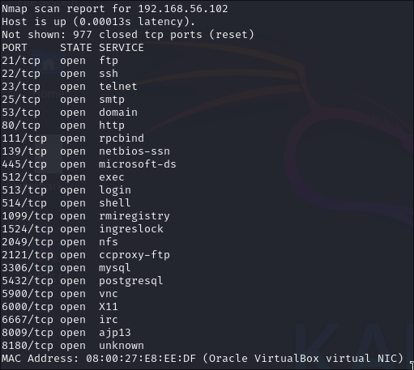

  - List the current firewall rules associated with your metasploitable virtual machine (if any).

Provide a screenshot.
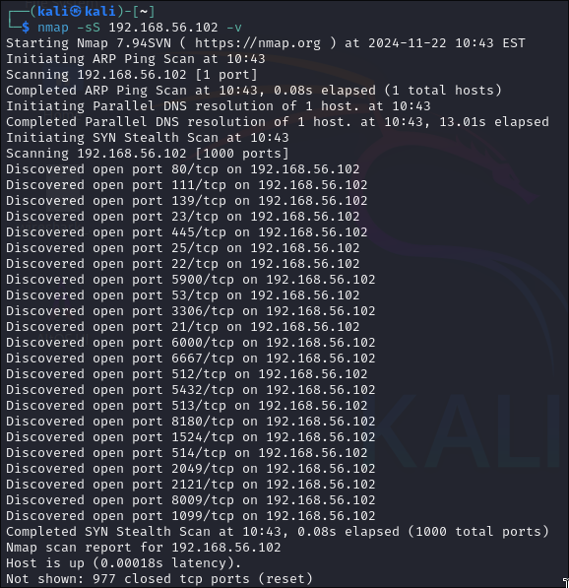

  - Produce a command to block any single IP address.
Provide the command or a screenshot.
iptables -A INPUT -s <IP_ADDRESS> -j DROP

  - Produce a command to block a range of IP Addresses.
Provide the command or a screenshot.
iptables -A INPUT -m iprange --src-range <START>-<END> -j DROP

  - Produce a command to block an incoming connection to SSH via a single port block.
Provide the command or a screenshot.
iptables -A INPUT -p tcp --dport ssh -s 192.168.56.102 -j DROP

  - Produce a command to block all incoming traffic, but allow SSH

Provide the command, and a screenshot that proves you can still allow SSH
iptables —policy INPUT DROP
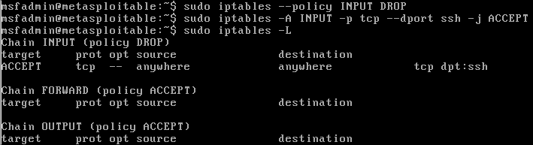

  - Utilize the command to block all traffic except for SSH on your metasploitable VM. Execute a scan from NMAP as evidence.

Provide the screenshot showing all services except ssh have been blocked.
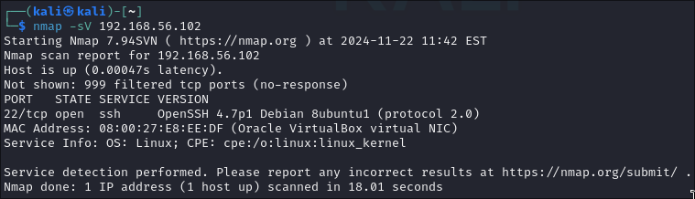

  - Delete all rules and return to the default state.
Provide the command and a screenshot showing the current ruleset.

iptables -F

