Prerequisites:
- Review Week 6 discussion of virtualization and virtualized networking (slide content).
- Review Week 6 discussion and working knowledge of Linux commands (slide content and tutorials).
- Metasploitable Virtual Machine

Objectives:
The main purpose of this week’s exercise is to learn how to exploit other technologies that Kali can help with and Metasploitable makes vulnerable.

Call for Help:
Do your best to try the tasks below, if you’re confused, or need help, feel free to email or text me at any point and I will gladly try to help you. If you’re having an Issue, chances are, other people are as well, and I can update the instructions/comments/add content as necessary.

Tasks:

Setup
- You’ll need both Kali and Metasploitable Running simultaneously. You can do this by running a virtual machine, or by pairing with a friend and running metasploitable over the network (be careful here).
- Make sure you follow the instructions from lecture, and ensure the networks are setup accordingly with your layout.

Intro:
- Refamiliarize yourself with the following sections from Offensive Security’s Website
  - Introduction
  - Metasploit Fundamentals
  - Information Gathering
https://www.offensive-security.com/metasploit-unleashed/

- Remember, your Kali virtual machine, and metasploitable virtual machines can easily be redownloaded if you encounter an error. Don’t be afraid to experiment.
- You’ll need the rpcbind package and the nfs-common package to run these steps. In Kali, while connected to the internet via NAT or Bridged Mode run the following two commands.
apt-get install rpcbind

apt-get install nfs-common

Network Scanning :
- Setup
- Go to the below link and request a trial of nessus. You’ll need the activation key to continue this part of the lesson. You can use your rowan email for this registration, or a disposable email address.
https://www.tenable.com/tenable-for-education/nessus-essentials?edu=true
- The below commands are to be run from Kali until otherwise noted.

- In Kali, open Firefox and use the above URL to download the appropriate architecture.

What linux family is Kali built on and what processor architecture is it?
Kali is built on Debian Linux and my installation is compiled for the amd64 architecture.

- Select the appropriate download for your kali architecture, download it to a location you will remember.
- Open a terminal, change to the download location and install nessus with the command

sudo dpkg -i <Nessus Package Name>

- Once the package is installed successfully, make sure it is added to the system control list:

systemctl enable --now nessusd

and Check the Status

systemctl status nessusd

- Open Firefox on Kali and go to https://127.0.0.1:8834 or https://localhost:8834

- Confirm any security exceptions to continue.
- When prompted create any username and password combination and use the activation key requested to finish setup. It will take some time to finish configuration
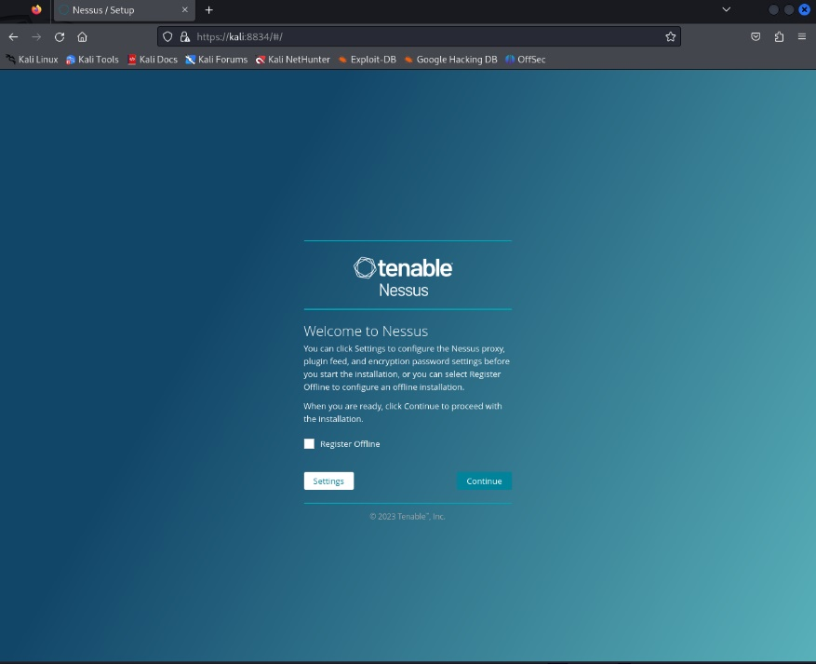

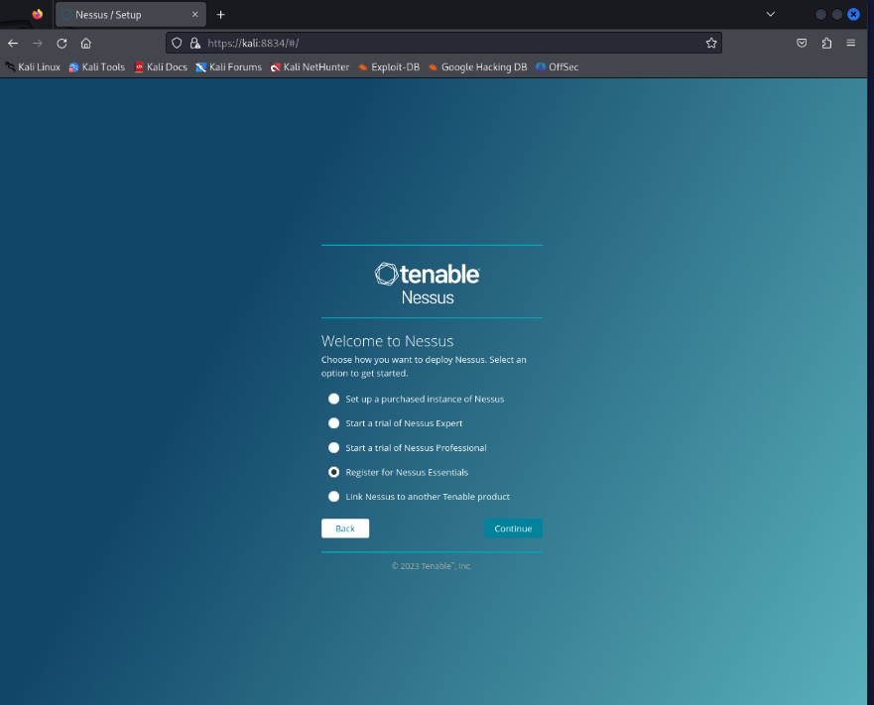
- Scanning
  - Click “New Scan” in the upper right corner.
  - Select “Advanced Scan”
  - Enter “Test Scan” like and add the target IP of your Metasploitable Virtual Machine.
  - Create another advanced scan called “Test Scan Credentialed”
  - Use the SSH Credentials, and use Password as the Authentication Method.
  - Use msfadmin and msfadmin for the username and password and select the sudo box for elevate privileges.
  - Save this scan.
  - Select the checkboxes next to each scan, and click “More” and “Launch”
- You can review the results by selecting the scans and selecting vulnerabilities.

Produce a screenshot of the two scans. What do you notice between the two scans?
What vulnerabilities look interesting?
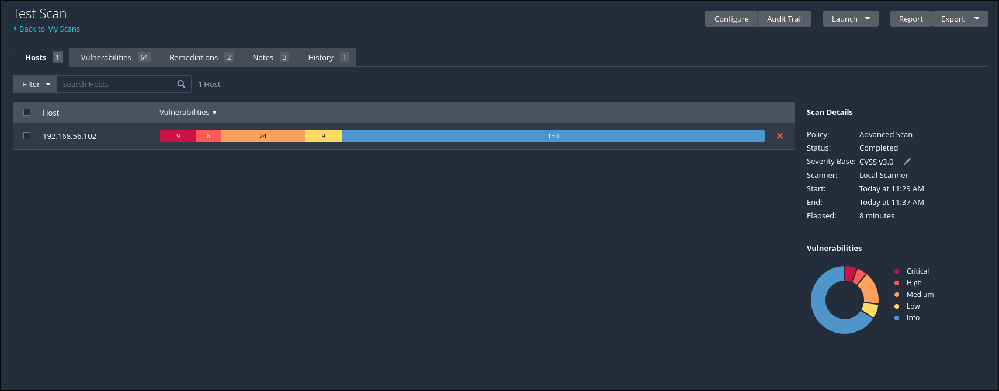
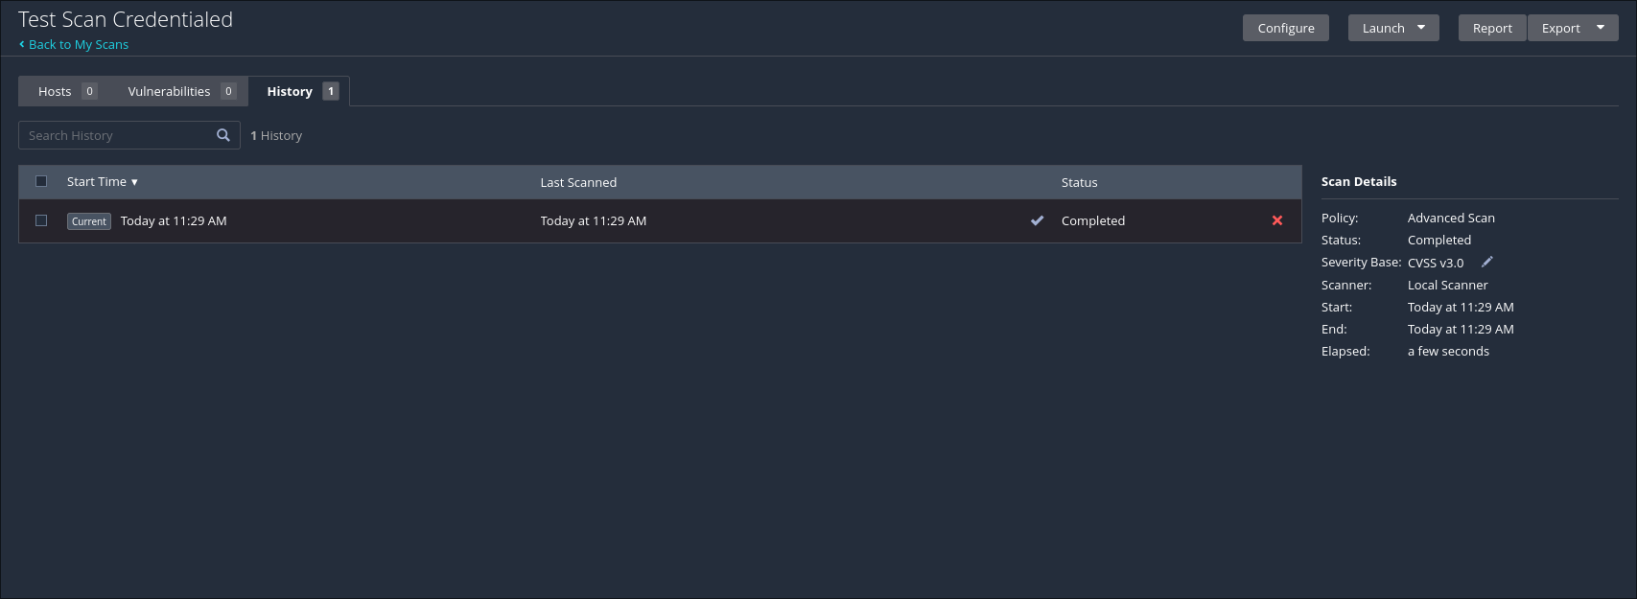

I noticed that the scan without credentials had a large number of vulnerabilities, while the credentialed test did not show any vulnerabilities. There were a lot of configuration-related vulnerabilities. For example encrypted servers and default credentials were among the most severe issues.

- Scan a friend or another computer, raspberry pi, etc that you own only. Produce an analysis of what you find.
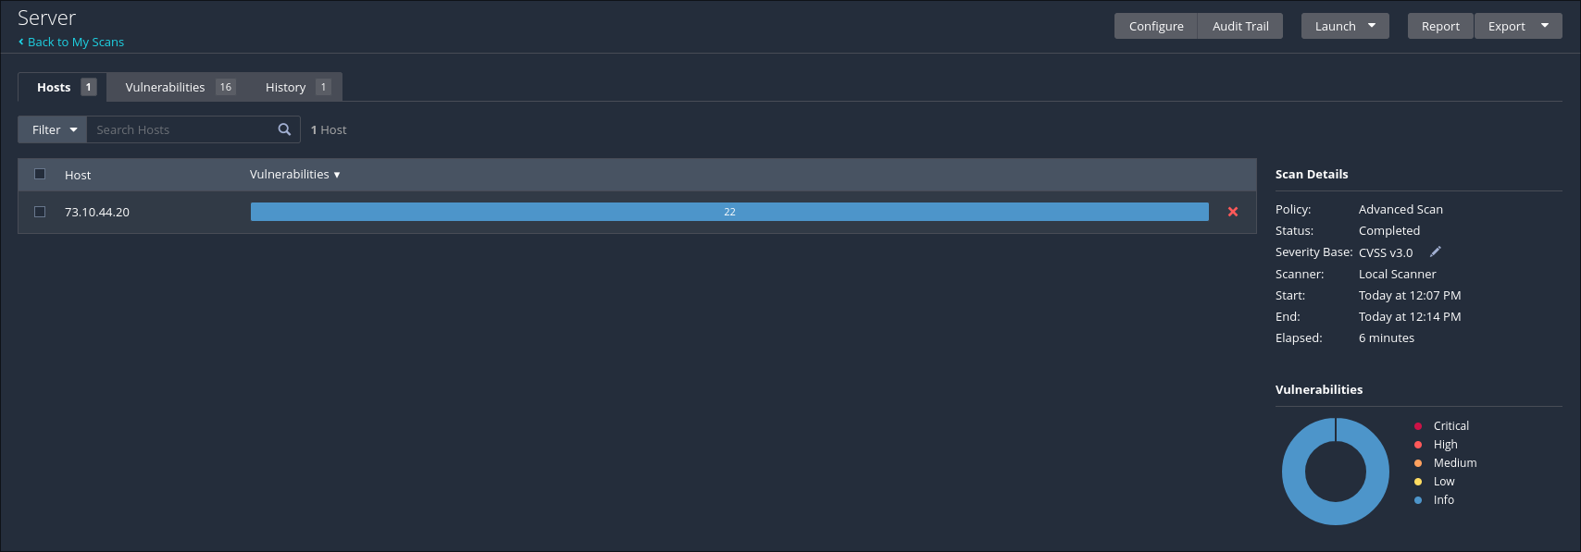
I scanned my home server and it did not find any threats. All vulnerabilities were only listed as “info”.

