Prerequisites:
- Review Week 6 discussion of virtualization and virtualized networking (slide content).
- Review Week 6 discussion and working knowledge of Linux commands (slide content and tutorials).
- Kali Linux Virtual Machine
Objectives:
The main purpose of this week’s exercise is getting started with Kali, understanding NMAP, and showing how it can be used for basic reconnaissance.

Call for Help:
Do your best to try the tasks below, if you’re confused, or need help, please post the message to the class message boards. If you’re having an Issue, chances are, other people are as well, and I can update the instructions/comments/add content as necessary.

Background:
Nmap (Network Mapper) is a free and open-source security scanner, originally written by Gordon Lyon, used to discover hosts and services on a computer network, thus building a "map" of the network. To accomplish its goal, Nmap sends specially crafted packets to the target host(s) and then analyzes the responses.

Tasks:

Fundamentals/Setup:
- If you’re using a virtual machine, make sure your Virtual Machine is in Bridged Mode.
Note: Recall that you may need to restart your virtual machine for things to take effect.
- Confirm your Virtual Machine and Physical Machine have different IP Addresses (ipconfig on most windows variants, and ifconfig on your Kali Linux Virtual Machine)
- Confirm you can ping a well-known URL or IP Address.

Provide a screenshot of the ping.
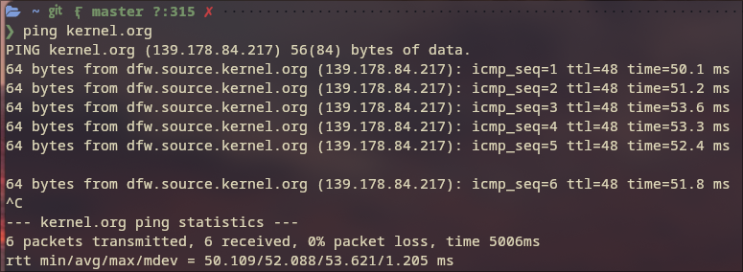

- Recall you can learn about Nmap if you have any challenges using the linux command man nmap. Feel free to look over nmap’s options. Use Page Up/Down to scroll through the many options.

Finding Hosts on Your Network:
- REVIEW THE BELOW TUTORIAL ON IP ADDRESSSES AND SUBNETTING (Introduction to Conclusion). You need to understand how IP Addressing works.
https://www.techopedia.com/6/28587/internet/8-steps-to-understanding-ip-subnetting
- Use the command nmap -sn <Network> to identify hosts on your network.
Note: As an example, my home network is 192.168.1.XXX, where XXX changes for every device I have. To find 192.168.1.0 to 192.168.1.255 I would use nmap -sn 192.168.1.0/24
Provide a screenshot of what you found.
lea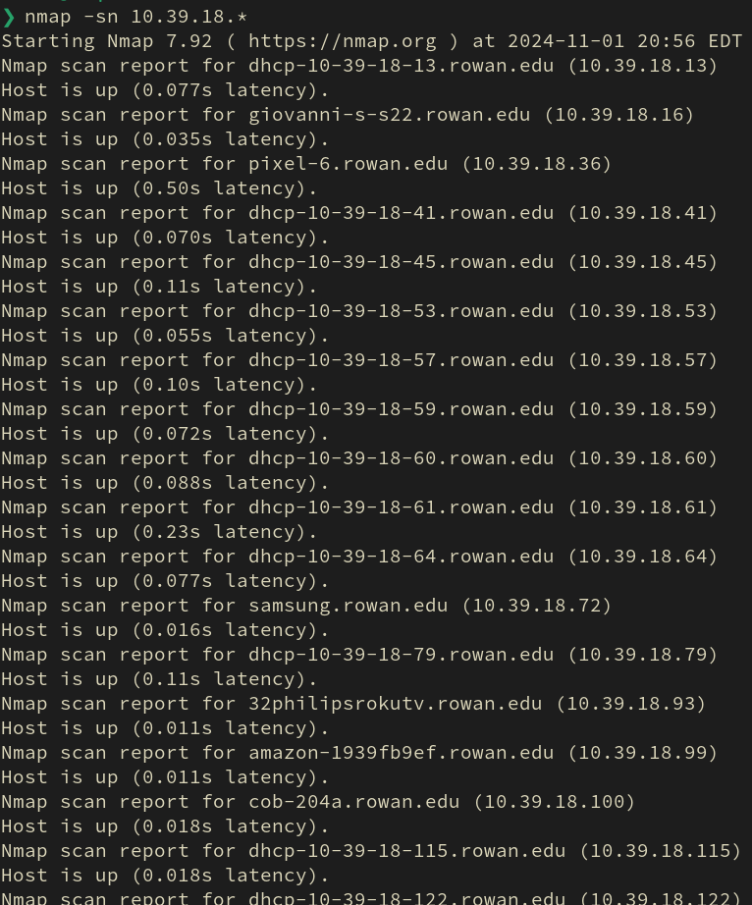
Question: What do you notice about the types of devices? Did nmap associate a MAC address to a Vendor?
- How it works: The Nmap option -sn disables port scanning, leaving the discovery phase enabled, which makes Nmap perform a ping sweep. Depending on the privileges, Nmap by default uses different techniques to achieve this task: sending a TCP SYN packet to port 443, TCP ACK packet to port 80 and ICMP echo and timestamp requests if executed as a privileged user, or a SYN packets to port 80 and 443 via the connect() syscall if executed by users who can't send raw packets. ARP/Neighbor Discovery is also enabled when scanning local Ethernet networks as privileged users. MAC addresses and vendors are identified from the ARP requests sent during the ARP/Neighbor Discovery phase.

Tracing Routes:
- Run the command nmap -sn --traceroute google.com microsoft.com
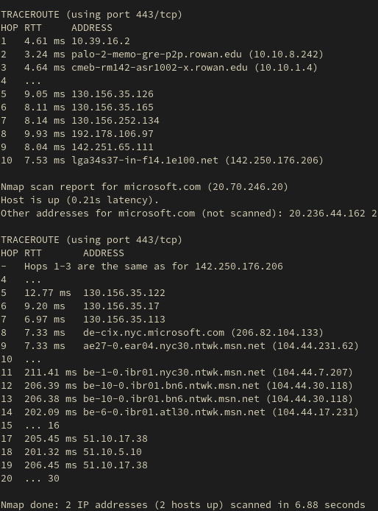
What did you find:
  - How Many Hops?
10 hops for Google, 30 hops for Microsoft.
  - Were there other hosts associated with microsoft.com and google.com? If so, why is this the case?
Microsoft.com had a lot of other host associated with it. This is because Microsoft owns a lot of hosts, and depending on you location, the DNS will connect you to whichever one will yield the least delay.
  - Anything else of interest?
The traceroute functionality was odd. First of all, it required root privileges, which was not expected. Second of all, it did not list all hops, it left some out for some reason, for example, no information is provided for hops 20 ... 30 for microsoft.com.

Finding Open Ports On a Given Host:
- Run the command nmap scanme.nmap.org
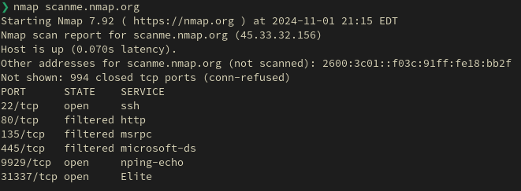
Provide a Screenshot
  - What ports are open?
22, 80, 135, 445, 9929, 31337
  - What are the services likely for?
Nping-echo is likely for responding to nmap pings, ssh is for remote access, and 31337 is supposed to read ‘eleet’, hence the service name Elite.

- How it works: The basic default Nmap scan nmap <target> executes a simple port scan that returns a list of ports. In addition, it returns a service name from a database distributed with Nmap and the port state for each of the listed ports.
Nmap categorizes ports into the following states:
  - Open: Open indicates that a service is listening for connections on this port.
  - Closed: Closed indicates that the probes were received, but it was concluded that there was no service running on this port.
  - Filtered: Filtered indicates that there were no signs that the probes were received and the state could not be established. It also indicates that the probes are being dropped by some kind of filtering.
  - Unfiltered: Unfiltered indicates that the probes were received but a state could not be established.
  - Open/Filtered: This indicates that the port was filtered or open but the state could not be established.
  - Close/Filtered: This indicates that the port was filtered or closed but the state could not be established.
Even for this simplest port scan, Nmap does many things in the background that can be configured as well.

Scan a friend:
- Work with a friend, or utilize another computer or asset (google home, alexa, playstation, etc., etc.) you own.
- Use NMAP to scan the host.
Provide a screenshot.
From a cybersecurity perspective, what did you learn? Are there any ports open, possibly vulnerable services, was it blocked by a firewall, etc.?

Your Mission:
- Discover hosts with a TCP SYN ping scan.
What command did you use?
nmap -sS
- Discover hosts with a TCP ACK ping scan.
What command did you use?
nmap -sT
- Discover hosts with a UDP ping scan.
What command did you use?
- Discover hosts with a SCTP INIT ping scan.
What command did you use?
- Discover hosts with an IP protocol ping scan.
What command did you use?

NMAP Scripting:
- Identify a potential target (like a webcam) or another device via Shodan.
Provide a screenshot of the device from Shodan.
- Utilize NMAP and its geolocation scripts to find the physical location of the given IP.
Provide a screenshot of the command and the result of the identified geolocation.

