Prerequisites:
- Kali Linux access through a virtual machine.
Objectives:
The main purpose of this week’s exercise is to learn how to basics of Linux, manipulation and common tools we will user.

Conventions:
Commands are typically in italics
Things that require submission are in red

What to Submit?
It’s best if you edit the document in line, with your additions in blue, and screenshots where they are requested.

Call for Help:
Do your best to try the tasks below, if you’re confused, or need help, start with the discussion board topic on Kali. If that doesn’t work, feel free to email or text me at any point and I will gladly try to help you. If you’re having an Issue, chances are, other people are as well, and I can update the instructions/comments/add content as necessary.

- Setup
  - Boot Up Kali Linux
  - Note the upper left corner of the screen. This is where most interaction will occur.
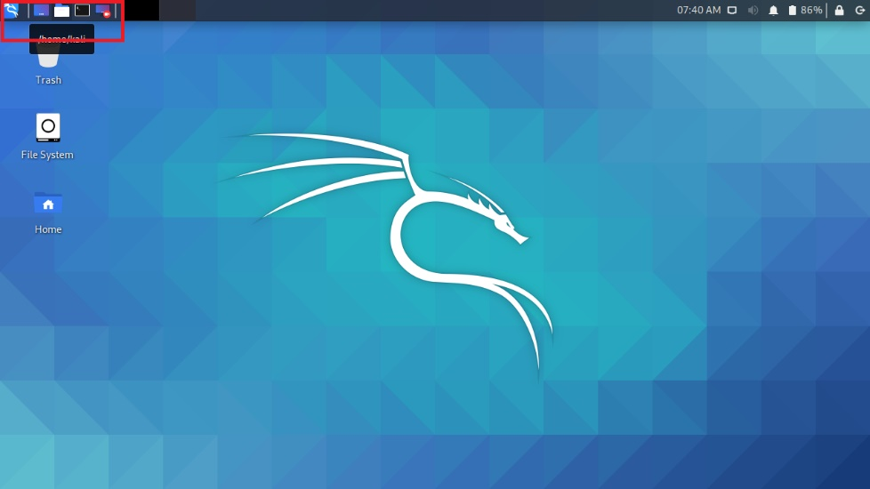
- Basic Interactions
  - Start a terminal by clicking the terminal button, or finding it from the program drop downs.
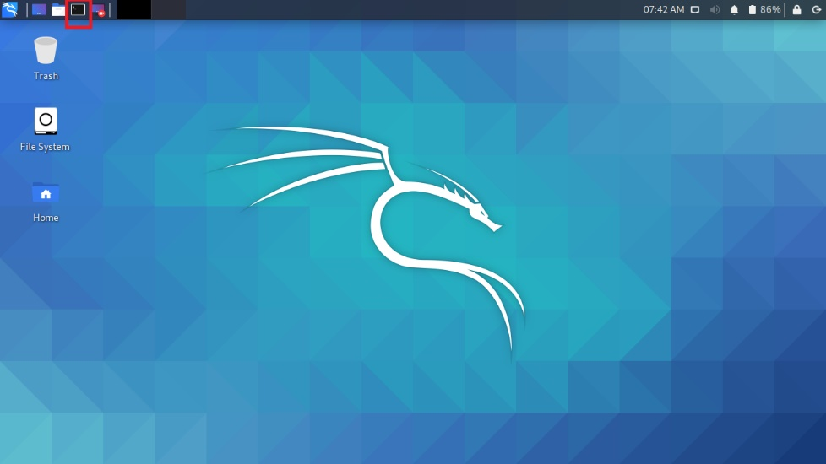
  - Can you determine your current username and host from just opening the shell?
Yes, the username and host name are both “kali”, hence kali@kali.
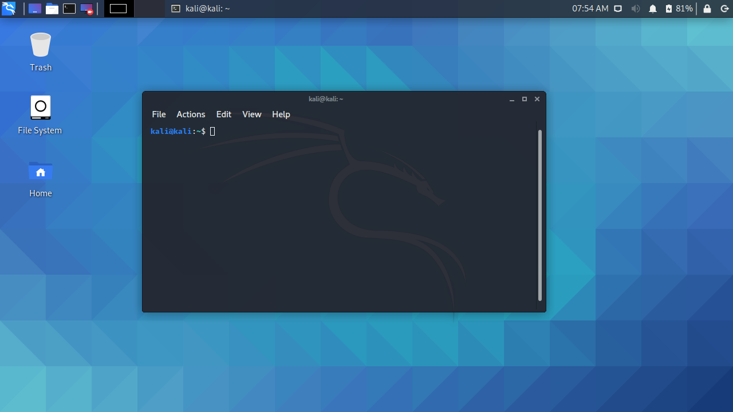
  - Utilize the pwd command to determine your current working directory.
What is your current working directory?
/home/kali
  - You can use the cd command to Change Directories. This can be done in a number of ways.
Note the commands demonstrated in the screenshot. What occurred, specifically the three different ways I used cd (cd .. cd /home/kali and cd ./kali)?
cd .. Changes the directory from /home/kali to /home/
cd /home/kali changed the directory from /home to /home/kali
cd ./kali changed the directory from /home to /home/kali using . to denote the current directory
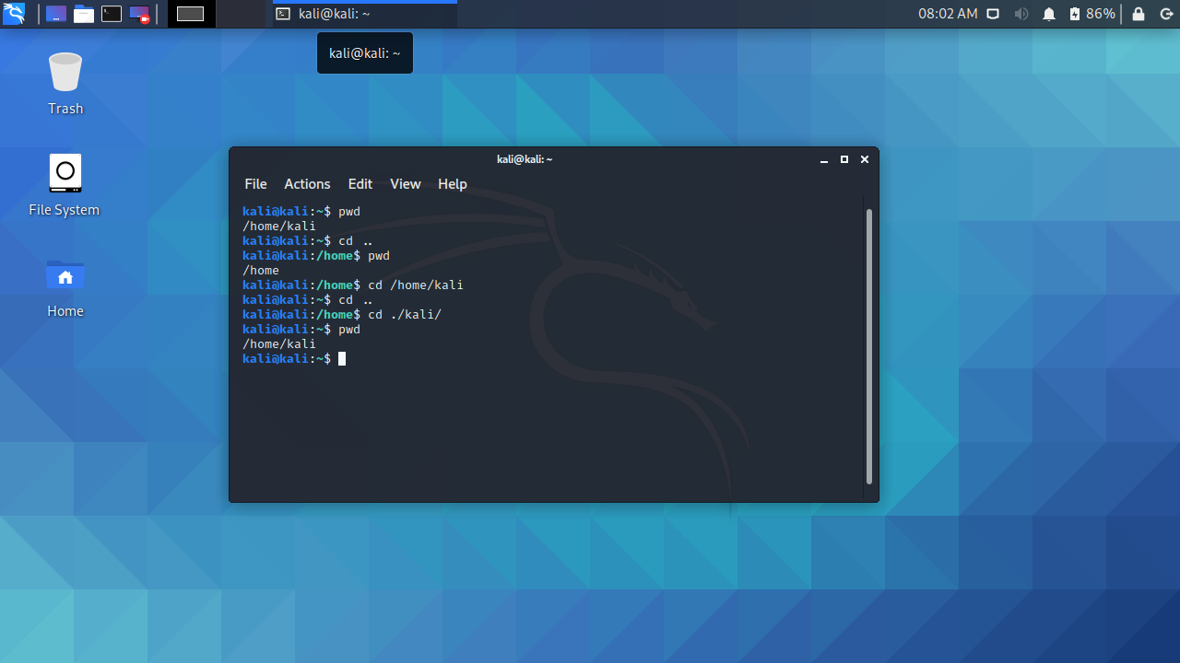
Longer List of Resources: https://www.gnu.org/software/bash/manual/bash.html
  - The whoami command us useful to return the user we are logged in as.
Note the commands demonstrated in the screenshot. Why did whoami return root the second time?
The first whoami was run as the kali user with user privileges, while the second time, whoami was run using sudo, which runs the command as the root user.
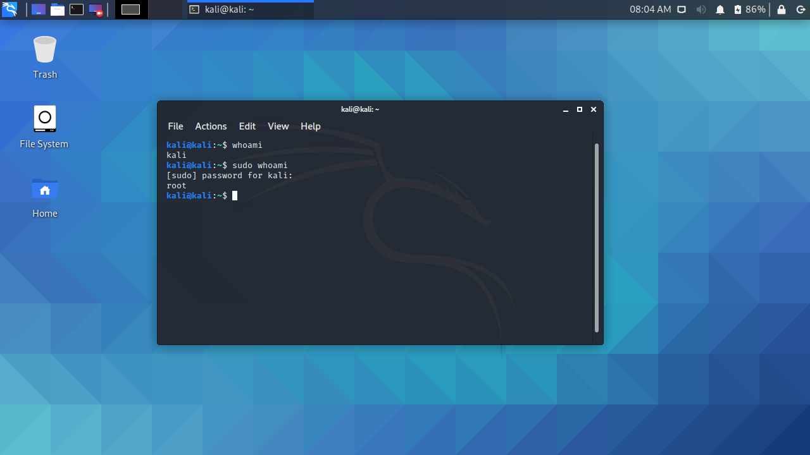

- Creating Directories and Files:
  - The command ls is very powerful and used to list contents of a directory or subdirectory so that we can learn about its contents or permissions.
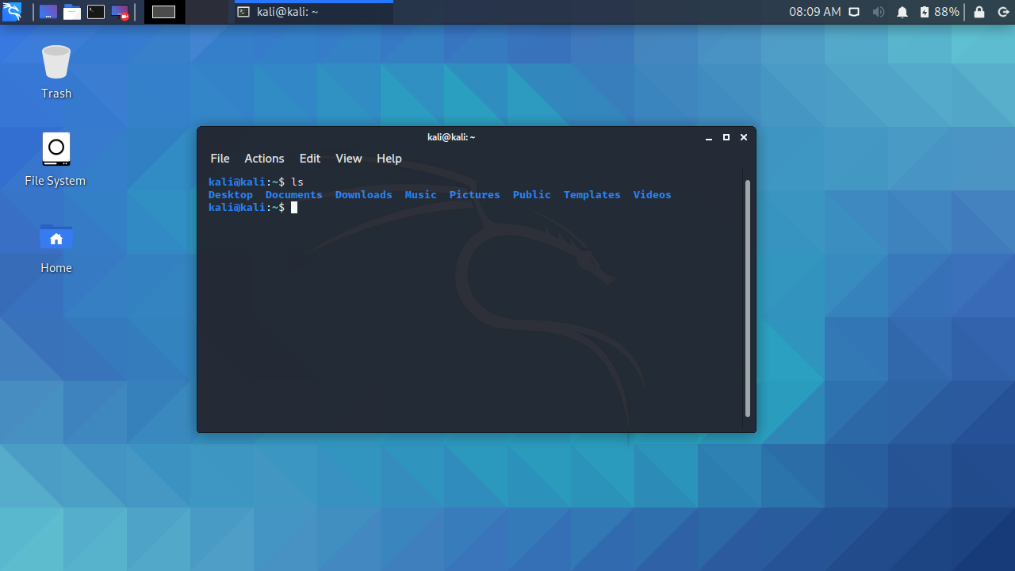
  - The command man is used to identify the details of a command through then manual. Most Linux commands utilize this functionality and it is very helpful with unfamiliar commands.
  - When you type a command such as man ls this will give you the details of the command, and you can navigate utilizing the Page Up and Page Down buttons, as well as the letter q to exit.
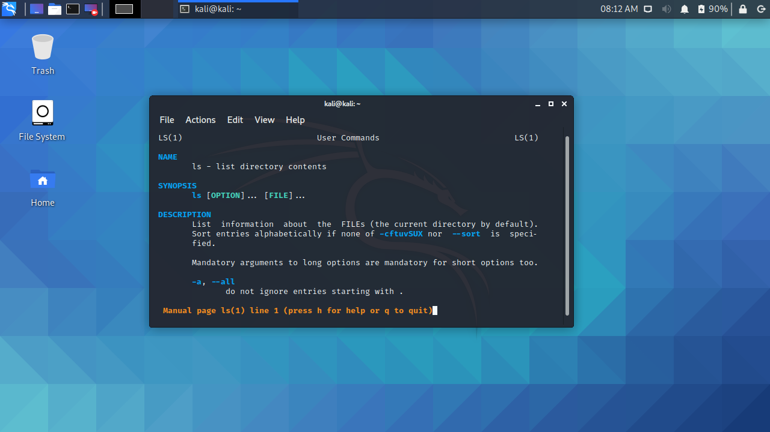
  - Utilizing the manual function please report the commands to do the following functions.
    - Show the file or directory, size, modified date and time, file or folder name and owner of file and its permission.
ls -l
    - Show hidden files in the current directory
ls -a will show all files, while ls –A will show all files excluding the implicit . and ..
    - Recursively list Sub-Directories.
ls -R
    - Sort Files by File Size
ls -S
  - The command touch is useful to create, change and modify timestamps of a file.
    - Copy or download any file into your virtual machine.
    - Show the timestamp of the file, wait a minute or so, and utilize the touch command to change the file timestamp. Submit a screenshot similar to this example. In this example, I’ve created a blank file called example.txt.
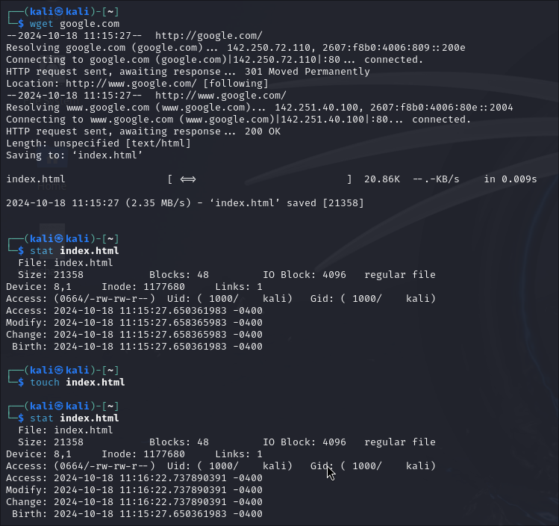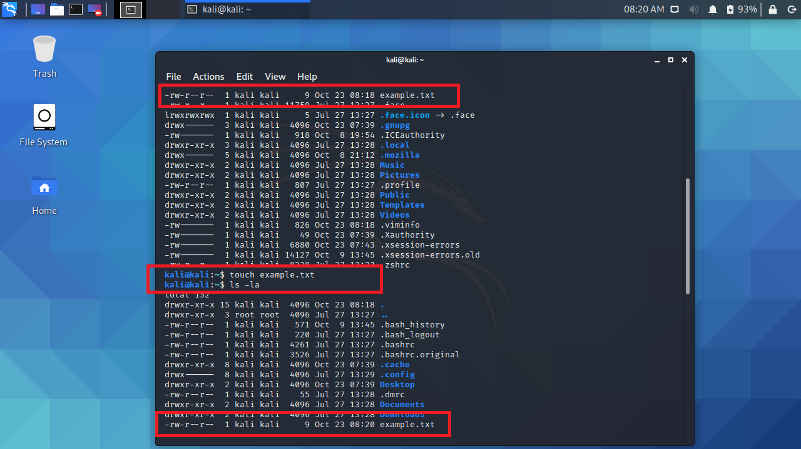
  - To create a directory, we need to utilize the mkdir command. Lookup the usage of the mkdir command utilizing the man command, make a directory and submit a screenshot.
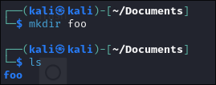
- Managing Files
  - The cp command is useful for copying files from one location to another.
    - Either by copying a new file, or utilizing the previous file you copied into your virtual machine, and the new directory you created in previous steps, submit a screenshot copying the file from one directory to another.
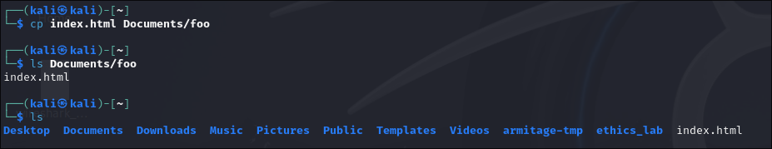
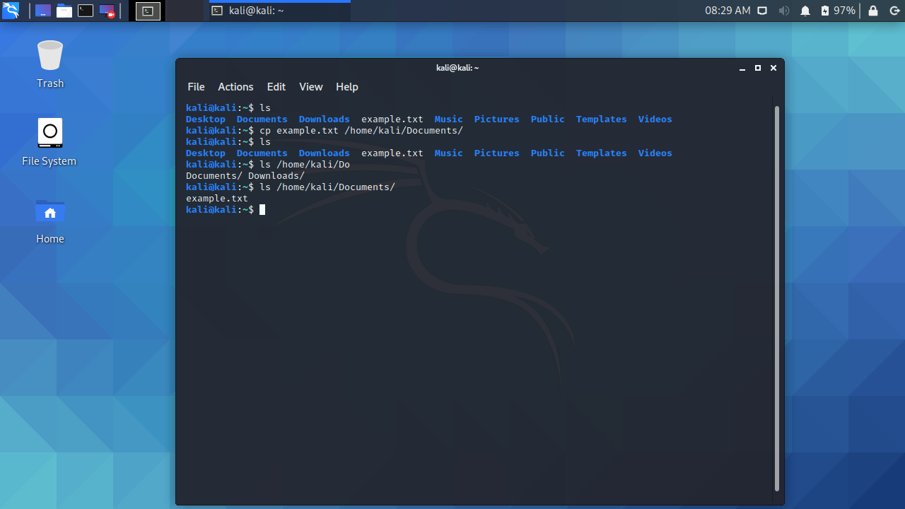
  - The mv command is useful for moving files, especially since linux does not have a rename command for specific files.
Rename a file of your choosing and submit a screenshot.
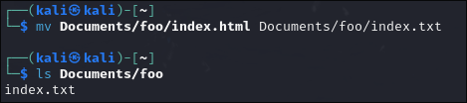
  - From the command line in the terminal we can view the contents of the file utilizing the cat command. This is short of concatenate.
  - Utilize the cat command to view the contents of /etc/xattr.conf from the command line and submit a screenshot.
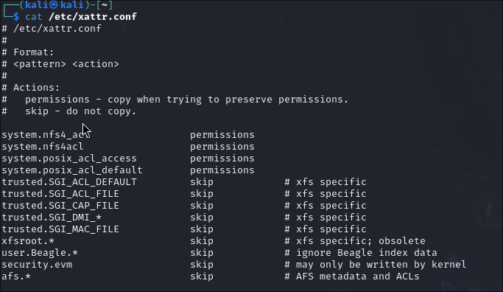
  - What happens if you run cat against a command like ls? For example, what does cat ls produce?
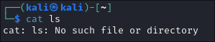
- Finding Files
  - Finding Files in a Directory
    - The command find is useful for finding things within a directory you’re looking for. By default, find is recursive and will discover every where a file is found.
    - Utilize the find command to search over one of the directories such as /etc to find a file that contains the name readme. Note that README and readme are two different files. Submit a screenshot.
Command run: find / readme
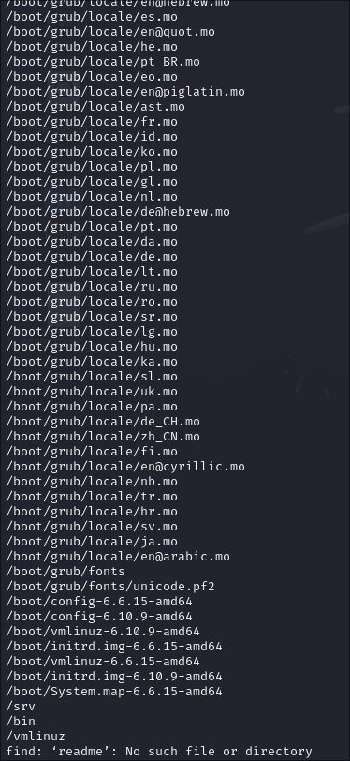
    - Did you notice any errors when you were searching over the directories recursively?
The search turned up empty. There were no files with the name “readme”.
  - Finding Binaries
    - The which command is useful for finding a path of a particular binary. Binaries are the functional equivalent of executables in windows.
    - Utilize the which command to locate the mv and sudo commands. Submit a screenshot.
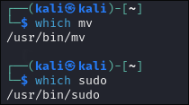

    - Next, try utilizing which to find ifconfig. Does which locate it?
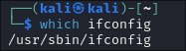
    - Run the command ls -la /usr/sbin/if*
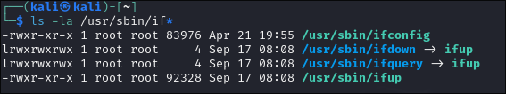
    - Do you note ifconfig? Any idea why which did not find it?
  - Other ways to find files
    - The locate command is also useful for finding files, but relies on an local database that must be updated.
    - Create a new file or copy a new file to the kali desktop.
    - Utilize the command sudo updatedb to update the locate database.
    - Attempt to locate the file by utilizing the command locate YOURFILENAME.
    - Change the name of the file to something new.
    - Again, attempt to locate the file. What do you notice? Submit a screenshot.
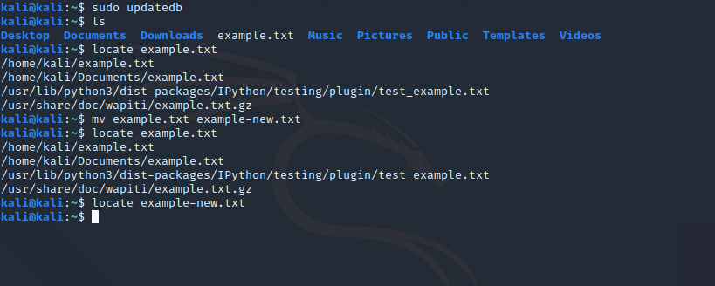

- Managing Software

  - One of the distinguishing characteristics about different versions of Linux is the use of different package management approaches. Kali uses APT or Advanced Package Tool, which is commonly found on Debian, Ubuntu and related Linux distributions of which Kali is one variant.

update is used to resynchronize the package index files from their sources. The lists of available packages are fetched from the location(s) specified in /etc/apt/sources.list.
upgrade is used to install the newest versions of all packages currently installed on the system from the sources enumerated in /etc/apt/sources.list. Packages currently installed with new versions available are retrieved and upgraded; under no circumstances are currently installed packages removed, or packages not already installed retrieved and installed. New versions of currently installed packages that cannot be upgraded without changing the install status of another package will be left at their current version.

full-upgrade (apt) and dist-upgrade (apt-get), in addition to performing the function of upgrade, also intelligently handles changing dependencies with new versions of packages; apt and apt-get have a "smart" conflict resolution system, and will attempt to upgrade the most important packages at the expense of less important ones if necessary. The /etc/apt/sources.list file contains a list of locations from which to retrieve desired package files.
  - Examine the sources list by utilizing cat /etc/apt/sources.lst Note these are the defaults.
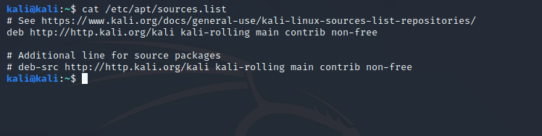
  - Run the following commands to update kali.
sudo apt update
sudo apt full-upgrade -y

  - To install a package, utilize apt-get install. For this example, we’re going to install thunderbird, which is a mail client utilized in many Linux Variants.
Utilize sudo apt-get install thunderbird. Submit a screenshot.
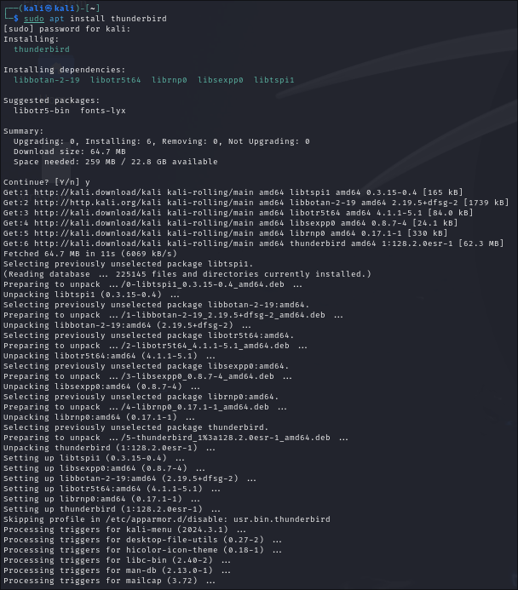
- Networking
  - Interface Information
    - The ifconfig command is used for administration of network interface information.
Note: You must be root to run this command.
    - Run the sudo ifconfig and report the ip address of your current virtual machine.
    - Does ifconfig report more than one adapter? If so, what are the names of the others and what are they used for? Submit a screenshot with your explanation.
There are two adapters eth0 and lo.
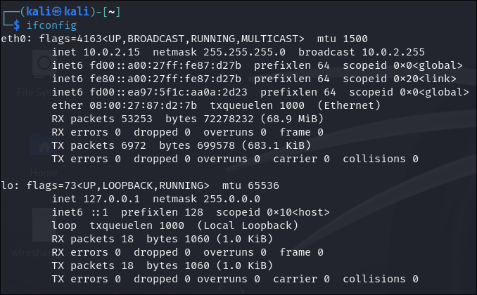
    - How would you change the MAC address of your adapter to something like “70:4D:7B:40:E3:3C”
sudo ip link set dev eth0 address 70:4D:7B:40:E3:3C

    - Change your virtual machine to between “Bridge” and “NAT” mode, rebooting inbetween. What do you note about your IP Address?
NAT: inet 10.0.2.15/24 brd 10.0.2.255 scope global dynamic noprefixroute eth0
Bridge: inet 10.39.18.119/20 brd 10.39.31.255 scope global dynamic noprefixroute eth0

  - Simple Diagnostics using ping
    - Utilize the ping command to ping google.com
    - Submit a screenshot and answer the following questions?
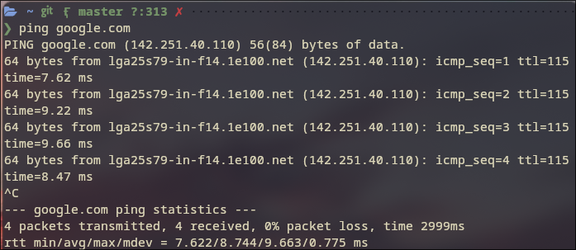
      - What is the IP Address of google.com?
142.251.40.110
      - What is the relevance of the icmp_seq, ttl and time?
The icmp_seq field is the ICMP sequence number. It is a counter that keeps track of the order of packets.
The ttl field (time to live) is the amount of time the packet is allowed to exist in the network
The time field is the amount of time elapsed between the request and the response.
  - Traceroute
    - First install the traceroute package using apt as in the previous examples.
    - Utilize the command traceroute to rowan.edu by traceroute rowan.edu.
- Netstat command.
  - Run the command netstat and netstat -r.
Utilizing man, what is the purpose of this command?
netstat - Print network connections, routing tables, interface statistics, masquerade connections, and multicast memberships

- Permissions
  - Utilizing the ls -l command we can see what permissions are on a particular file. The below screenshot provides a good explanation of Linux permissions.
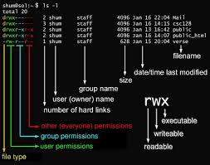
  - Create a new file by utilizing the command sudo touch /home/kali/newfile.txt
    - What are the permissions of the newly created file?
-rw-r--r--
    - Who is the owner of the file?
root
  - Utilize man or google fu, to be able to do the following:
    - What commands would I use to change the file to a new user and group ownership?
chmod
    - What permissions would I set to disallow ‘other’ users to be able to read the file?
sudo chmod o-r newfile.txt
    - How would I add execute permissions to all users?
sudo chmod +x newfile.txt
- Managing Processes
  - In Linux, a process is a program running in memory. Typically, your computer is running hundreds of processes simultaneously. If they're system processes, Linux folks refer to them as daemons or demons. You will often see the process name ending with a "d" such httpd, the process or daemon responsible for the http service.
  - Running Processes
    - The ps command us insight into the processes that are currently running.
    - You can see all running process on your system by typing ps aux
    - What information is given to us about the running processes with the above switches?
User, PID, %CPU, %MEM, VSZ, RSS, TTY, Stat, Start, Time, Command

  - Current Resources
    - The top command provides us with the top processes that are using the most resources in real time.
    - With the exception of the top command, what is the most resource intensive process on your system currently? What is its purpose?
Xorg, the active display server, is consuming the most resources. Its purpose is to provide an interface for the desktop environment to work with to display windows and other graphics.
  - Ending a process
    - The command kill is used to end a process.
    - Kill can be used to kill a process by id, or name.
    - Review the kill manual pages and answer the following questions:
      - How would you kill all process that you own?
kill -9

