Quiz Practice
- Consider the periodic signal given in the figure below.

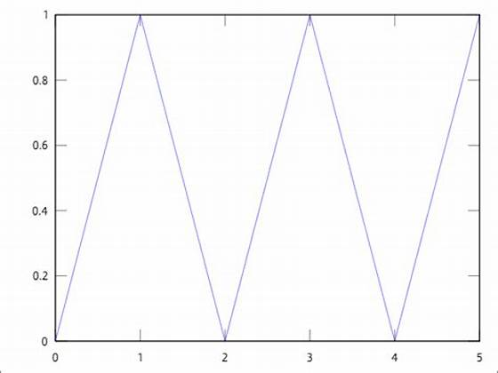

- Is this signal finite support or infinite support?
- Is this signal causal or not cauisal?
- Is this signal even, odd or neither?
- What is the period of the signal?
- Calculate the energy of the signal.
- Calculate the power of the signal.
- The trigonometric Fourier series is given by

$$x\left(t\right)= c_{0}+2\sum_{k=1}^{∞}{[c_{k}\cos\left(kΩ_{0}t\right)+}d_{k}\sin\left(kΩ_{0}t\right)]$$

Calculate the DC term.
Write the integral expressions for $c_{k}$ and $d_{k}$
Do not carry out the calculations for $c_{k}$ and $d_{k}$
- Consider the suystem given by:

$$y\left(t\right)=S\left[x\left(t\right)\right]=\left(t+3\right)\cos\left(t-3\right)x(t)$$

- Is the system linear?
- Is the system time-invariant?
- Is the system cauysal?
- Is the system BIBO stable?

- Consider the causal LTI system with impulse response h(t) and transfer function given by:

$$H\left(s\right)=\frac{s+3}{s(s-1)}$$

- What are the zeros?
- What are the poles?
- Is the system BIBO stable?
- If the input to the system is x(t) = cos(t) u(t) where u(t) is the unit-step, find the output y(t).

