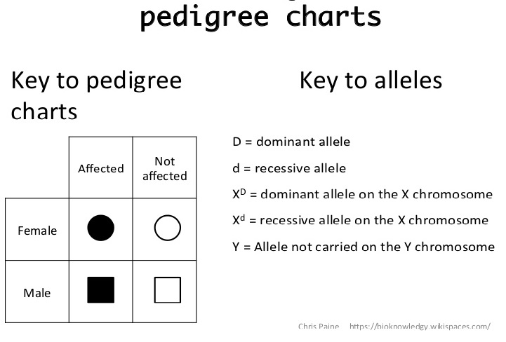
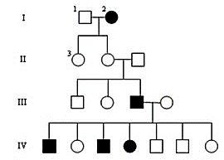
Answer the following 5 questions about the inheritance of Hemophilia in the pedigree depicted to the left.

- How many males are there?
There are 7 males.
- How many males have hemophilia?
There are 3 affected males.
- How many females are there?
There are 8 females.
- How many females have hemophilia?
There are 2 affected females.
- How many marriages are there?
There are 3 marriages.

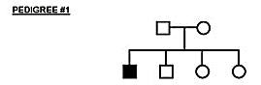
Could this trait be inherited as……. | Check Yes or No |  | If Yes, then suggest the genotypes
 | Yes | No | Father’s Genotype | Mother’s Genotype
Autosomal recessive?
Autosomal dominant?
X linked recessive?
X linked dominant?
Y linked trait?

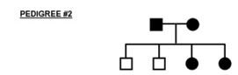
Could this trait be inherited as……. | Check Yes or No |  | If Yes, then suggest the genotypes
 | Yes | No | Father’s Genotype | Mother’s Genotype
Autosomal recessive?
Autosomal dominant?
X linked recessive?
X linked dominant?
Y linked trait?

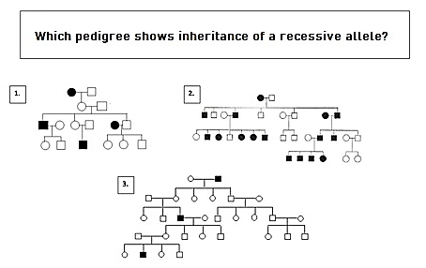
Check the correct answer
1 | 2 | 3

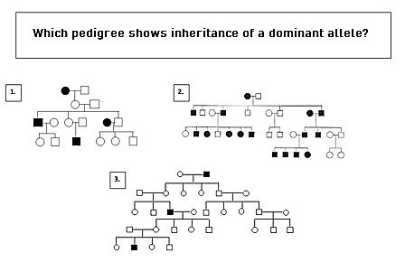
Check the correct answer
1 | 2 | 3

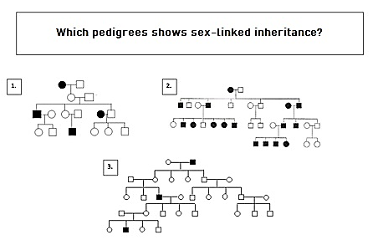
Check the correct answer
1 | 2 | 3

